

KOMISI ETIK PENELITIAN KESEHATAN

*HEALTH RESEARCH ETHICS COMMITTEE*

POLITEKNIK KESEHATAN KEMENKES MALANG

*STATE POLYTECHNIC OF HEALTH MALANG*

**KETERANGAN LOLOS KAJI ETIK**

*DESCRIPTION OF ETHICAL APPROVAL*

*"ETHICAL APPROVAL"*

***Reg.No.:608 / KEPK-POLKESMA/ 2020***

Protokol penelitian yang diusulkan oleh Lovy Fiara Zuninda Rahmawati

*The research protocol proposed by*

|  |  |
| --- | --- |
| Peneliti Utama | **Lovy Fiara Zuninda Rahmawati** |
| *Principal In Investigator* |

Nama Institusi Poltekkes Malang

*Name of the Institution*

Dengan Judul

Pengaruh Pelatihan Manajemen ASI Perah (ASIP) Terhadap Pemahaman Tentang ASI Eksklusif Pada Ibu Hamil TrimesterIII Di PUSKESMAS Pandanwangi Kota Malang

***The Effect Of Training Of Dairy Management Towards Understanding Of Exclusive Breast Milk In Third Trimester Pregnant Mother At Primary Health Care Pandanwangi District Of Malang***

Dinyatakan layak etik sesuai 7 (tujuh) Standar WHO 2011, yaitu 1) Nilai Sosial, 2) Nilai Ilmiah, 3) Pemerataan Beban dan Manfaat, 4) Risiko, 5) Bujukan/Eksploitasi,

6) Kerahasiaan dan Privacy, dan 7) Persetujuan Setelah Penjelasan, yang merujuk pada Pedoman CIOMS 2016. Hal ini seperti yang ditunjukkan oleh terpenuhinya indikator setiap standar.

*Declared to be ethically appropriate in accordance to 7 (seven) WHO 2011 Standards, 1) Social Values, 2) Scientific Values, 3) Equitable Assessment and Benefits, 4) Risks,*

*5) Persuasion/Exploitation, 6) Confidentiality and Privacy, and 7) Informed Concent, referring to the 2016 CIOMS Guidelines. This is as indicated by the fulfillment of the indicators of each standard.*

Pernyataan Laik Etik ini berlaku selama kurun waktu tanggal 03 Februari 2020 sampai dengan 03 Februari 2021

*This declaration of ethics applies during the period February 3, 2020 until February 3, 2021*

Malang, 03 Februari 2020

Head of Committee

Dr. SUSI MILWATI, S.Kp, M.Pd

NIP. 196312011987032002

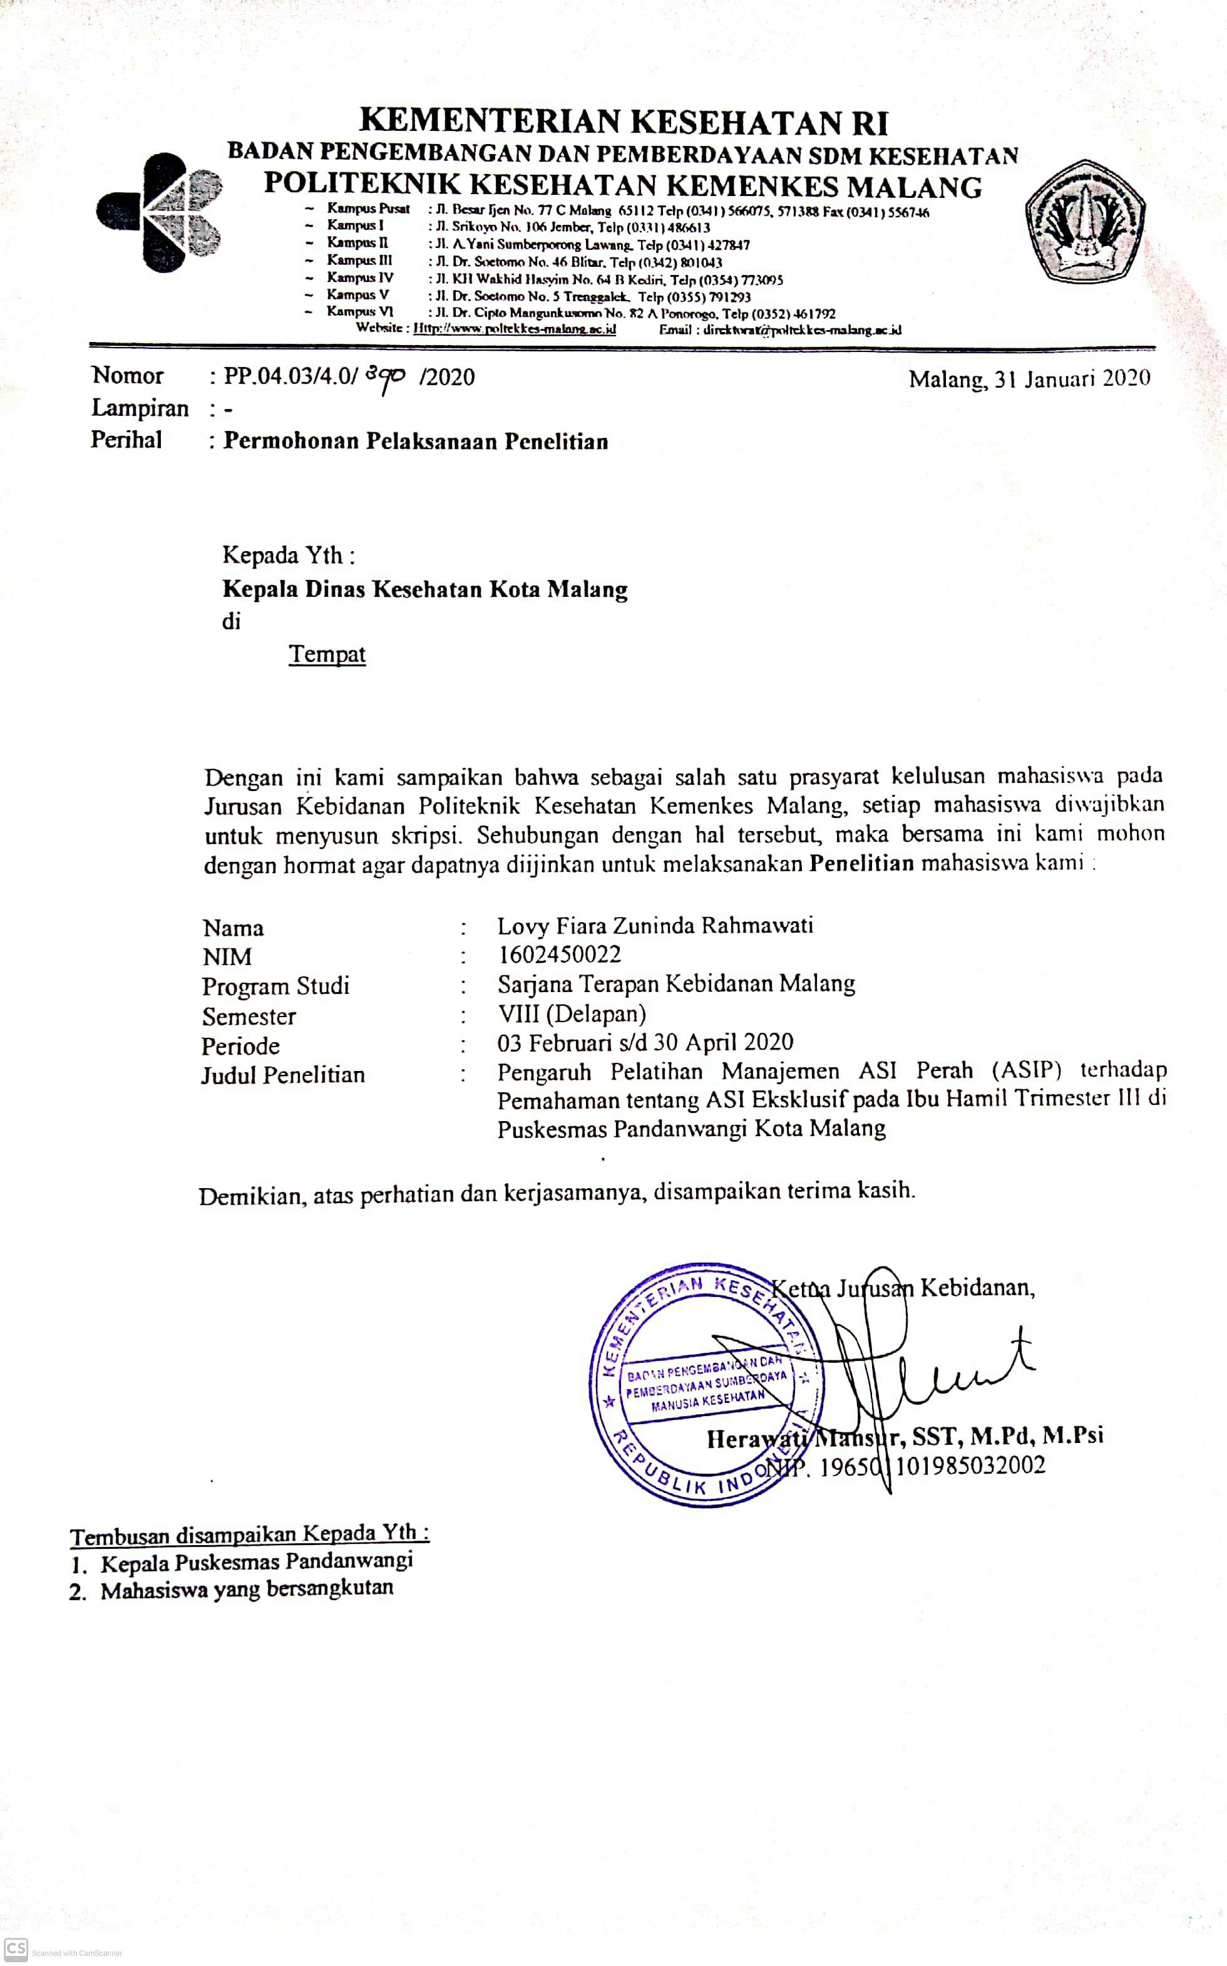**Lampiran 2**

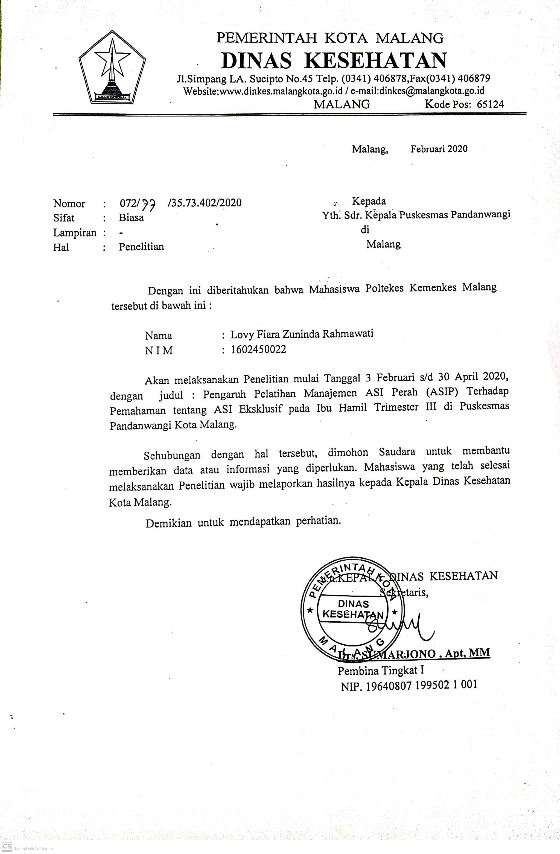

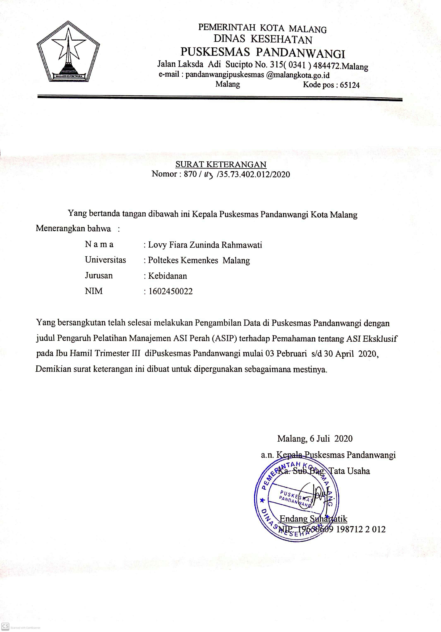

**Lampiran 3**

**Hasil Uji Validitas dan Reliabilitas**

| Item | r Hitung | r Tabel | Ket | Item | r Hitung | r Tabel | Ket | Item | r Hitung | r Tabel | Ket |
| --- | --- | --- | --- | --- | --- | --- | --- | --- | --- | --- | --- |
| 1 | 0.606 | 0.444 | Valid | 25 | 0.332 | 0.444 | Tidak Valid | 49 | 0.446 | 0.444 | Valid |
| 2 | 0.711 | 0.444 | Valid | 26 | 0.629 | 0.444 | Valid | 50 | 0.654 | 0.444 | Valid |
| 3 | 0.468 | 0.444 | Valid | 27 | 0.711 | 0.444 | Valid | 51 | 0.125 | 0.444 | Tidak Valid |
| 4 | 0.744 | 0.444 | Valid | 28 | 0.389 | 0.444 | Tidak Valid | 52 | -0,409 | 0.444 | Tidak Valid |
| 5 | 0.164 | 0.444 | Tidak Valid | 29 | 0.738 | 0.444 | Valid | 53 | 0.482 | 0.444 | Valid |
| 6 | 0.655 | 0.444 | Valid | 30 | 0.911 | 0.444 | Valid | 54 | 0.711 | 0.444 | Valid |
| 7 | -0,022 | 0.444 | Tidak Valid | 31 | 0.388 | 0.444 | Tidak Valid | 55 | -0,031 | 0.444 | Tidak Valid |
| 8 | 0.253 | 0.444 | Tidak Valid | 32 | -0,035 | 0.444 | Tidak Valid | 56 | -0,053 | 0.444 | Tidak Valid |
| 9 | 0.212 | 0.444 | Tidak Valid | 33 | 0.197 | 0.444 | Tidak Valid | 57 | -0,017 | 0.444 | Tidak Valid |
| 10 | 0.789 | 0.444 | Valid | 34 | 0.594 | 0.444 | Valid | 58 | 0.793 | 0.444 | Valid |
| 11 | 0.738 | 0.444 | Valid | 35 | -0,077 | 0.444 | Tidak Valid | 59 | 0.489 | 0.444 | Valid |
| 12 | 0.557 | 0.444 | Valid | 36 | 0.878 | 0.444 | Valid | 60 | 0.57 | 0.444 | Valid |
| 13 | 0.548 | 0.444 | Valid | 37 | -0,371 | 0.444 | Tidak Valid | 61 | -0,158 | 0.444 | Tidak Valid |
| 14 | 0.154 | 0.444 | Tidak Valid | 38 | 0.143 | 0.444 | Tidak Valid | 62 | 0.722 | 0.444 | Valid |
| 15 | 0.411 | 0.444 | Tidak Valid | 39 | 0.096 | 0.444 | Tidak Valid | 63 | 0.189 | 0.444 | Tidak Valid |
| 16 | 0.294 | 0.444 | Tidak Valid | 40 | 0.647 | 0.444 | Valid | 64 | 0.340 | 0.444 | Tidak Valid |
| 17 | 0.344 | 0.444 | Tidak Valid | 41 | -0,253 | 0.444 | Tidak Valid | 65 | -0.565 | 0.444 | Valid |
| 18 | 0.911 | 0.444 | Valid | 42 | 0,184 | 0.444 | Tidak Valid | 66 | 0.516 | 0.444 | Valid |
| 19 | 0.823 | 0.444 | Valid | 43 | 0.482 | 0.444 | Valid | 67 | 0.388 | 0.444 | Tidak Valid |
| 20 | 0.516 | 0.444 | Valid | 44 | 0.226 | 0.444 | Tidak Valid | 68 | -0,008 | 0.444 | Tidak Valid |
| 21 | 0.548 | 0.444 | Valid | 45 | -0,008 | 0.444 | Tidak Valid | 69 | 0.288 | 0.444 | Tidak Valid |
| 22 | 0.289 | 0.444 | Tidak Valid | 46 | 0.091 | 0.444 | Tidak Valid | 70 | 0.509 | 0.444 | Valid |
| 23 | 0.255 | 0.444 | Tidak Valid | 47 | 0.238 | 0.444 | Tidak Valid | 71 | 0.534 | 0.444 | Valid |
| 24 | 0.352 | 0.444 | Tidak Valid | 48 | 0.762 | 0.444 | Valid | 72 | 0.669 | 0.444 | Valid |

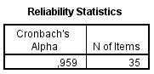

**Lampiran 4**

**Uji Normalitas**

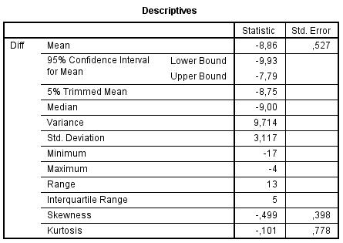

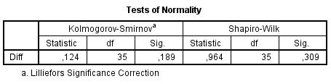

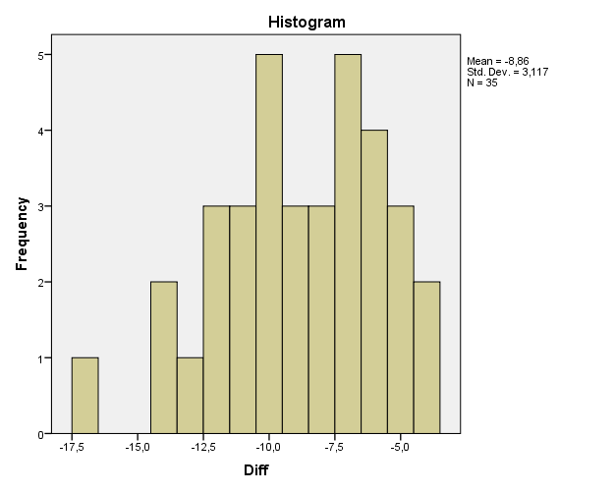

**Lampiran 5**

**Uji Hipotesis**

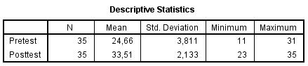



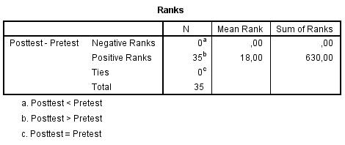

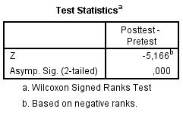

|  |  |  |  |  |  |  |  |  |  |  |  |  |  |  |  |  |  |  |  |  |  |  |  |  |  |  |  |  |  |  |  |  |  |  |  |  |  |  |  |  |  |  |  |  |  |  |  |  |  |  |  |  |  |  |  |  |  |  |  |  |  |  |  |  |  |  |  |  |  |  |  |  |  |  |  |  |  |  |  |  |  |  |  |  |  |  |  |  |  |  |  |  |  |  |  |  |  |  |  |  |  |  |  |  |  |  |  |  |  |  |  |  |  |  |  |  |  |  |  |  |  |  |  |  |  |  |  |  |  |  |  |  |  |  |  |  |  |  |  |  |  |  |  |  |  |  |  |  |  |  |  |  |  |  |  |  |  |  |  |  |  |  |  |  |  |  |  |  |  |  |  |  |  |  |  |  |  |  |  |  |  |  |  |  |  |  |  |  |  |  |  |  |  |  |  |  |  |  |  |  |  |  |  |  |  |  |  |  |  |  |  |  |  |  |  |  |  |  |  |  |  |  |  |  |  |  |  |  |  |  |  |  |  |  |  |  |  |  |  |  |  |  |  |  |  |  |  |  |  |  |  |  |  |  |  |  |  |  |  |  |  |  |  |  |  |  |  |  |  |  |  |  |  |  |  |  |  |  |  |  |  |  |  |  |  |  |  |  |  |  |  |  |  |  |  |  |  |  |  |  |  |  |  |  |  |  |  |  |  |  |  |  |  |  |  |  |  |  |  |  |  |  |  |  |  |  |  |  |  |  |  |  |  |  |  |  |  |  |  |  |  |  |  |  |  |  |  |  |  |  |  |  |  |  |  |  |  |  |  |  |  |  |  |  |  |  |  |  |  |  |  |  |  |  |  |  |  |  |  |  |  |  |  |  |  |  |  |  |  |  |  |  |  |  |  |  |  |  |  |  |  |  |  |  |  |  |  |  |  |  |  |  |  |  |  |  |  |  |  |  |  |  |  |  |  |  |  |  |  |  |  |  |  |  |  |  |  |  |  |  |  |  |  |  |  |  |  |  |  |  |  |  |  |  |  |  |  |  |  |  |  |  |  |  |  |  |  |  |  |  |  |  |  |  |  |  |  |  |  |  |  |  |  |  |  |  |  |  |  |  |  |  |  |  |  |  |  |  |  |  |  |  |  |  |  |  |  |  |  |  |  |  |  |  |  |  |  |  |  |  |  |  |  |  |  |  |  |  |  |  |  |  |  |  |  |  |  |  |  |  |  |  |  |  |  |  |  |  |  |  |  |  |  |  |  |  |  |  |  |  |  |  |  |  |  |  |  |  |  |  |  |  |  |  |  |  |  |  |  |  |  |  |  |  |  |  |  |  |  |  |  |  |  |  |  |  |  |  |  |  |  |  |  |  |  |  |  |  |  |  |  |  |  |  |  |  |  |  |  |  |  |  |  |  |  |  |  |  |  |  |  |  |  |  |  |  |  |  |  |  |  |  |  |  |  |  |  |  |  |  |  |  |  |  |  |  |  |  |  |  |  |  |  |  |  |  |  |  |  |  |  |  |  |  |  |  |  |  |  |  |  |  |  |  |  |  |  |  |  |  |  |  |  |  |  |  |  |  |  |  |  |  |  |  |  |  |  |  |  |  |  |  |  |  |  |  |  |  |  |  |  |  |  |  |  |  |  |  |  |  |  |  |  |  |  |  |  |  |  |  |  |  |  |  |  |  |  |  |  |  |  |  |  |  |  |  |  |  |  |  |  |  |  |  |  |  |  |  |  |  |  |  |  |  |  |  |  |  |  |  |  |  |  |  |  |  |  |  |  |  |  |  |  |  |  |  |  |  |  |  |  |  |  |  |  |  |  |  |  |  |  |  |  |  |  |  |  |  |  |  |  |  |  |  |  |  |  |  |  |  |  |  |  |  |  |  |  |  |  |  |  |  |  |  |  |  |  |  |  |  |  |  |  |  |  |  |  |  |  |  |  |  |  |  |  |  |  |  |  |  |  |  |  |  |  |  |  |  |  |  |  |  |  |  |  |  |  |  |  |  |  |  |  |  |  |  |  |  |  |  |  |  |  |  |  |  |  |  |  |  |  |  |  |  |  |  |  |  |  |  |  |  |  |  |  |  |  |  |  |  |  |  |  |  |  |  |  |  |  |  |  |  |  |  |  |  |  |  |  |  |  |  |  |  |  |  |  |  |  |  |  |  |  |  |  |  |  |  |  |  |  |  |  |  |  |  |  |  |  |  |  |  |  |  |  |  |  |  |  |  |  |  |  |  |  |  |  |  |  |  |  |  |  |  |  |  |  |  |  |  |  |  |  |  |  |  |  |  |  |  |  |  |  |  |  |  |  |  |  |  |  |  |  |  |  |  |  |  |  |  |  |  |  |  |  |  |  |  |  |  |  |  |  |  |  |  |  |  |  |  |  |  |  |  |  |  |  |  |  |  |  |  |  |  |  |  |  |  |  |  |  |  |  |  |  |  |  |  |  |  |  |  |  |  |  |  |  |  |  |  |  |  |  |  |  |  |  |  |  |  |  |  |  |  |  |  |  |  |  |  |  |  |  |  |  |  |  |  |  |  |  |  |  |  |  |  |  |  |  |  |  |  |  |  |  |  |  |  |  |  |  |  |  |  |  |  |  |  |  |  |  |  |  |  |  |  |  |  |  |  |  |  |  |  |  |  |  |  |  |  |  |  |  |  |  |  |  |  |  |  |  |  |  |  |  |  |  |  |  |  |  |  |  |  |  |  |  |  |  |  |  |  |  |  |  |  |  |  |  |  |  |  |  |  |  |  |  |  |  |  |  |  |  |  |  |  |  |  |  |  |  |  |  |  |  |  |  |  |  |  |  |  |  |  |  |  |  |  |  |  |  |  |  |  |  |  |  |  |  |  |  |  |  |  |  |  |  |  |  |  |  |  |  |  |  |  |  |  |  |  |  |  |  |  |  |  |  |  |  |  |  |  |  |  |  |  |  |  |  |  |  |  |  |  |  |  |  |  |  |  |  |  |  |  |  |  |  |  |  |  |  |  |  |  |  |  |  |  |  |  |  |  |  |  |  |  |  |  |  |  |  |  |  |  |  |  |  |  |  |  |  |  |  |  |  |  |  |  |  |  |  |  |  |  |  |  |  |  |  |  |  |  |  |  |  |  |  |  |  |  |  |  |  |  |  |  |  |  |  |  |  |  |  |  |  |  |  |  |  |  |  |  |  |  |  |  |  |  |  |  |  |  |  |  |  |  |  |  |  |  |  |  |  |  |  |  |  |  |  |  |  |  |  |  |  |  |  |  |  |  |  |  |  |  |  |  |  |  |  |  |  |  |  |  |  |  |  |  |  |  |  |  |  |  |  |  |  |  |  |  |  |  |  |  |  |  |  |  |  |  |  |  |  |  |  |  |  |  |  |  |  |  |  |  |  |  |  |  |  |  |  |  |  |  |  |  |  |  |  |  |  |  |  |  |  |  |  |  |  |  |  |  |  |  |  |  |  |  |  |  |  |  |  |  |  |  |  |  |  |  |  |  |  |  |  |  |  |  |  |  |  |  |  |  |  |  |  |  |  |  |  |  |  |  |  |  |  |  |  |  |  |  |  |  |  |  |  |  |  |  |  |  |  |  |  |  |  |  |  |  |  |  |  |  |  |  |  |  |  |  |  |  |  |  |  |  |  |  |  |  |  |  |  |  |  |  |  |  |  |  |  |  |  |  |  |  |  |  |  |  |  |  |  |  |  |  |  |  |  |  |  |  |  |  |  |  |  |  |  |  |  |  |  |  |  |  |  |  |  |  |  |  |  |  |  |  |  |  |  |  |  |  |  |  |  |  |  |  |  |  |  |  |  |  |  |  |  |  |  |  |  |  |  |  |  |  |  |  |  |  |  |  |  |  |  |  |  |  |  |  |  |  |  |  |  |  |  |  |  |  |  |  |  |  |  |  |  |  |  |  |  |  |  |  |  |  |  |  |  |  |  |  |  |  |  |  |  |  |  |  |  |  |  |  |  |  |  |  |  |  |  |  |  |  |  |  |  |  |  |  |  |  |  |  |  |  |  |  |  |  |  |  |  |  |  |  |  |  |  |  |  |  |  |  |  |  |  |  |  |  |  |  |  |  |  |  |  |  |  |  |  |  |  |  |  |  |  |  |  |  |  |  |  |  |  |  |  |  |  |  |  |  |  |  |  |  |  |  |  |  |  |  |  |  |  |  |  |  |  |  |  |  |  |  |  |  |  |  |  |  |  |  |  |  |  |  |  |  |  |  |  |  |  |  |  |  |  |  |  |  |  |  |  |  |  |  |  |  |  |  |  |  |  |  |  |  |  |  |  |  |  |  |  |  |  |  |  |  |  |  |  |  |  |  |  |  |  |  |  |  |  |  |  |  |  |  |  |  |  |  |  |  |  |  |  |  |  |  |  |  |  |  |  |  |  |  |  |  |  |  |  |  |  |  |  |  |  |  |  |  |  |  |  |  |  |  |  |  |  |  |  |  |  |  |  |  |  |  |  |  |  |  |  |  |  |  |  |  |  |  |  |  |  |  |  |  |  |  |  |  |  |  |  |  |  |  |  |  |  |  |  |  |  |  |  |  |  |  |  |  |  |  |  |  |  |  |  |  |  |  |  |  |  |  |  |  |  |  |  |  |  |  |  |  |  |  |  |  |  |  |  |  |  |  |  |  |  |  |  |  |  |  |  |  |  |  |  |  |  |  |  |  |  |  |  |  |  |  |  |  |  |  |  |  |  |  |  |  |  |  |  |  |  |  |  |  |  |  |  |  |  |  |  |  |  |  |  |  |  |  |  |  |  |  |  |  |  |  |  |  |  |  |  |  |  |  |  |  |  |  |  |  |  |  |  |  |  |  |  |  |  |  |  |  |  |  |  |  |  |  |  |  |  |  |  |  |  |  |  |  |  |  |  |  |  |  |  |  |  |  |  |  |  |  |  |  |  |  |  |  |  |  |  |  |  |  |  |  |  |  |  |  |  |  |  |  |  |  |  |  |  |  |  |  |  |  |  |  |  |  |  |  |  |  |  |  |  |  |  |  |  |  |  |  |  |  |  |  |  |  |  |  |  |  |  |  |  |  |  |  |  |  |  |  |  |  |  |  |  |  |  |  |  |  |  |  |  |  |  |  |  |  |  |  |  |  |  |  |  |  |  |  |  |  |  |  |  |  |  |  |  |  |  |  |  |  |  |  |  |  |  |  |  |  |  |  |  |  |  |  |  |  |  |  |  |  |  |  |  |  |  |  |  |  |  |  |  |  |  |  |  |  |  |  |  |  |  |  |  |  |  |  |  |  |  |  |  |  |  |  |  |  |  |  |  |  |  |  |  |  |  |  |  |  |  |  |  |  |  |  |  |  |  |  |  |  |  |  |  |  |  |  |  |  |  |  |  |  |  |  |  |  |  |  |  |  |  |  |  |  |  |  |  |  |  |  |  |  |  |  |  |  |  |  |  |  |  |  |  |  |  |  |  |  |  |  |  |  |  |  |  |  |  |  |  |  |  |  |  |  |  |  |  |  |  |  |  |  |  |  |  |  |  |  |  |  |  |  |  |  |  |  |  |  |  |  |  |  |  |  |  |  |  |  |  |  |  |  |  |  |  |  |  |  |  |  |  |  |  |  |  |  |  |  |  |  |  |  |  |  |  |  |  |  |  |  |  |  |  |  |  |  |  |  |  |  |  |  |  |  |  |  |  |  |  |  |  |  |  |  |  |  |  |  |  |  |  |  |  |  |  |  |  |  |  |  |  |  |  |  |  |  |  |  |  |  |  |  |  |  |  |  |  |  |  |  |  |  |  |  |  |  |  |  |  |  |  |  |  |  |  |  |  |  |  |  |  |  |  |  |  |  |  |  |  |  |  |  |  |  |  |  |  |  |  |  |  |  |  |  |  |  |  |  |  |  |  |  |  |  |  |  |  |  |  |  |  |  |  |  |  |  |  |  |  |  |  |  |  |  |  |  |  |  |  |  |  |  |  |  |  |  |  |  |  |  |  |  |  |  |  |  |  |  |  |  |  |  |  |  |  |  |  |  |  |  |  |  |  |  |  |  |  |  |  |  |  |  |  |  |  |  |  |  |  |  |  |  |  |  |  |  |  |  |  |  |  |  |  |  |  |  |  |  |  |  |  |  |  |  |  |  |  |  |  |  |  |  |  |  |  |  |  |  |  |  |  |  |  |  |  |  |  |  |  |  |  |  |  |  |  |  |  |  |  |  |  |  |  |  |  |  |  |  |  |  |  |  |  |  |  |  |  |  |  |  |  |  |  |  |  |  |  |  |  |  |  |  |  |  |  |  |  |  |  |  |  |  |  |  |  |  |  |  |  |  |  |  |  |  |  |  |  |  |  |  |  |  |  |  |  |  |  |  |  |  |  |  |  |  |  |  |  |  |  |  |  |  |  |  |  |  |  |  |  |  |  |  |  |  |  |  |  |  |  |  |  |  |  |  |  |  |  |  |  |  |  |  |  |  |  |  |  |  |  |  |  |  |  |  |  |  |  |  |  |  |  |  |  |  |  |  |  |  |  |  |  |  |  |  |  |  |  |  |  |  |  |  |  |  |  |  |  |  |  |  |  |  |  |  |  |  |  |  |  |  |  |  |  |  |  |  |  |  |  |  |  |  |  |  |  |  |  |  |  |  |  |  |  |  |  |  |  |  |  |  |  |  |  |  |  |  |  |  |  |  |  |  |  |  |  |  |  |  |  |  |  |  |  |  |  |  |  |  |  |  |  |  |  |  |  |  |  |  |  |  |  |  |  |  |  |  |  |  |  |  |  |  |  |  |  |  |  |  |  |  |  |  |  |  |  |  |  |  |  |  |  |  |  |  |  |  |  |  |  |  |  |  |  |  |  |  |  |  |  |  |  |  |  |  |  |  |  |  |  |  |  |  |  |  |  |  |  |  |  |  |  |  |  |  |  |  |  |  |  |  |  |  |  |  |  |  |  |  |  |  |  |  |  |  |  |  |  |  |  |  |  |  |  |  |  |  |  |  |  |  |  |  |  |  |  |  |  |  |  |  |  |  |  |  |  |  |  |  |  |  |  |  |  |  |  |  |  |  |  |  |  |  |  |  |  |  |  |  |  |  |  |  |  |  |  |  |  |  |  |  |  |  |  |  |  |  |  |  |  |  |  |  |  |  |
| --- | --- | --- | --- | --- | --- | --- | --- | --- | --- | --- | --- | --- | --- | --- | --- | --- | --- | --- | --- | --- | --- | --- | --- | --- | --- | --- | --- | --- | --- | --- | --- | --- | --- | --- | --- | --- | --- | --- | --- | --- | --- | --- | --- | --- | --- | --- | --- | --- | --- | --- | --- | --- | --- | --- | --- | --- | --- | --- | --- | --- | --- | --- | --- | --- | --- | --- | --- | --- | --- | --- | --- | --- | --- | --- | --- | --- | --- | --- | --- | --- | --- | --- | --- | --- | --- | --- | --- | --- | --- | --- | --- | --- | --- | --- | --- | --- | --- | --- | --- | --- | --- | --- | --- | --- | --- | --- | --- | --- | --- | --- | --- | --- | --- | --- | --- | --- | --- | --- | --- | --- | --- | --- | --- | --- | --- | --- | --- | --- | --- | --- | --- | --- | --- | --- | --- | --- | --- | --- | --- | --- | --- | --- | --- | --- | --- | --- | --- | --- | --- | --- | --- | --- | --- | --- | --- | --- | --- | --- | --- | --- | --- | --- | --- | --- | --- | --- | --- | --- | --- | --- | --- | --- | --- | --- | --- | --- | --- | --- | --- | --- | --- | --- | --- | --- | --- | --- | --- | --- | --- | --- | --- | --- | --- | --- | --- | --- | --- | --- | --- | --- | --- | --- | --- | --- | --- | --- | --- | --- | --- | --- | --- | --- | --- | --- | --- | --- | --- | --- | --- | --- | --- | --- | --- | --- | --- | --- | --- | --- | --- | --- | --- | --- | --- | --- | --- | --- | --- | --- | --- | --- | --- | --- | --- | --- | --- | --- | --- | --- | --- | --- | --- | --- | --- | --- | --- | --- | --- | --- | --- | --- | --- | --- | --- | --- | --- | --- | --- | --- | --- | --- | --- | --- | --- | --- | --- | --- | --- | --- | --- | --- | --- | --- | --- | --- | --- | --- | --- | --- | --- | --- | --- | --- | --- | --- | --- | --- | --- | --- | --- | --- | --- | --- | --- | --- | --- | --- | --- | --- | --- | --- | --- | --- | --- | --- | --- | --- | --- | --- | --- | --- | --- | --- | --- | --- | --- | --- | --- | --- | --- | --- | --- | --- | --- | --- | --- | --- | --- | --- | --- | --- | --- | --- | --- | --- | --- | --- | --- | --- | --- | --- | --- | --- | --- | --- | --- | --- | --- | --- | --- | --- | --- | --- | --- | --- | --- | --- | --- | --- | --- | --- | --- | --- | --- | --- | --- | --- | --- | --- | --- | --- | --- | --- | --- | --- | --- | --- | --- | --- | --- | --- | --- | --- | --- | --- | --- | --- | --- | --- | --- | --- | --- | --- | --- | --- | --- | --- | --- | --- | --- | --- | --- | --- | --- | --- | --- | --- | --- | --- | --- | --- | --- | --- | --- | --- | --- | --- | --- | --- | --- | --- | --- | --- | --- | --- | --- | --- | --- | --- | --- | --- | --- | --- | --- | --- | --- | --- | --- | --- | --- | --- | --- | --- | --- | --- | --- | --- | --- | --- | --- | --- | --- | --- | --- | --- | --- | --- | --- | --- | --- | --- | --- | --- | --- | --- | --- | --- | --- | --- | --- | --- | --- | --- | --- | --- | --- | --- | --- | --- | --- | --- | --- | --- | --- | --- | --- | --- | --- | --- | --- | --- | --- | --- | --- | --- | --- | --- | --- | --- | --- | --- | --- | --- | --- | --- | --- | --- | --- | --- | --- | --- | --- | --- | --- | --- | --- | --- | --- | --- | --- | --- | --- | --- | --- | --- | --- | --- | --- | --- | --- | --- | --- | --- | --- | --- | --- | --- | --- | --- | --- | --- | --- | --- | --- | --- | --- | --- | --- | --- | --- | --- | --- | --- | --- | --- | --- | --- | --- | --- | --- | --- | --- | --- | --- | --- | --- | --- | --- | --- | --- | --- | --- | --- | --- | --- | --- | --- | --- | --- | --- | --- | --- | --- | --- | --- | --- | --- | --- | --- | --- | --- | --- | --- | --- | --- | --- | --- | --- | --- | --- | --- | --- | --- | --- | --- | --- | --- | --- | --- | --- | --- | --- | --- | --- | --- | --- | --- | --- | --- | --- | --- | --- | --- | --- | --- | --- | --- | --- | --- | --- | --- | --- | --- | --- | --- | --- | --- | --- | --- | --- | --- | --- | --- | --- | --- | --- | --- | --- | --- | --- | --- | --- | --- | --- | --- | --- | --- | --- | --- | --- | --- | --- | --- | --- | --- | --- | --- | --- | --- | --- | --- | --- | --- | --- | --- | --- | --- | --- | --- | --- | --- | --- | --- | --- | --- | --- | --- | --- | --- | --- | --- | --- | --- | --- | --- | --- | --- | --- | --- | --- | --- | --- | --- | --- | --- | --- | --- | --- | --- | --- | --- | --- | --- | --- | --- | --- | --- | --- | --- | --- | --- | --- | --- | --- | --- | --- | --- | --- | --- | --- | --- | --- | --- | --- | --- | --- | --- | --- | --- | --- | --- | --- | --- | --- | --- | --- | --- | --- | --- | --- | --- | --- | --- | --- | --- | --- | --- | --- | --- | --- | --- | --- | --- | --- | --- | --- | --- | --- | --- | --- | --- | --- | --- | --- | --- | --- | --- | --- | --- | --- | --- | --- | --- | --- | --- | --- | --- | --- | --- | --- | --- | --- | --- | --- | --- | --- | --- | --- | --- | --- | --- | --- | --- | --- | --- | --- | --- | --- | --- | --- | --- | --- | --- | --- | --- | --- | --- | --- | --- | --- | --- | --- | --- | --- | --- | --- | --- | --- | --- | --- | --- | --- | --- | --- | --- | --- | --- | --- | --- | --- | --- | --- | --- | --- | --- | --- | --- | --- | --- | --- | --- | --- | --- | --- | --- | --- | --- | --- | --- | --- | --- | --- | --- | --- | --- | --- | --- | --- | --- | --- | --- | --- | --- | --- | --- | --- | --- | --- | --- | --- | --- | --- | --- | --- | --- | --- | --- | --- | --- | --- | --- | --- | --- | --- | --- | --- | --- | --- | --- | --- | --- | --- | --- | --- | --- | --- | --- | --- | --- | --- | --- | --- | --- | --- | --- | --- | --- | --- | --- | --- | --- | --- | --- | --- | --- | --- | --- | --- | --- | --- | --- | --- | --- | --- | --- | --- | --- | --- | --- | --- | --- | --- | --- | --- | --- | --- | --- | --- | --- | --- | --- | --- | --- | --- | --- | --- | --- | --- | --- | --- | --- | --- | --- | --- | --- | --- | --- | --- | --- | --- | --- | --- | --- | --- | --- | --- | --- | --- | --- | --- | --- | --- | --- | --- | --- | --- | --- | --- | --- | --- | --- | --- | --- | --- | --- | --- | --- | --- | --- | --- | --- | --- | --- | --- | --- | --- | --- | --- | --- | --- | --- | --- | --- | --- | --- | --- | --- | --- | --- | --- | --- | --- | --- | --- | --- | --- | --- | --- | --- | --- | --- | --- | --- | --- | --- | --- | --- | --- | --- | --- | --- | --- | --- | --- | --- | --- | --- | --- | --- | --- | --- | --- | --- | --- | --- | --- | --- | --- | --- | --- | --- | --- | --- | --- | --- | --- | --- | --- | --- | --- | --- | --- | --- | --- | --- | --- | --- | --- | --- | --- | --- | --- | --- | --- | --- | --- | --- | --- | --- | --- | --- | --- | --- | --- | --- | --- | --- | --- | --- | --- | --- | --- | --- | --- | --- | --- | --- | --- | --- | --- | --- | --- | --- | --- | --- | --- | --- | --- | --- | --- | --- | --- | --- | --- | --- | --- | --- | --- | --- | --- | --- | --- | --- | --- | --- | --- | --- | --- | --- | --- | --- | --- | --- | --- | --- | --- | --- | --- | --- | --- | --- | --- | --- | --- | --- | --- | --- | --- | --- | --- | --- | --- | --- | --- | --- | --- | --- | --- | --- | --- | --- | --- | --- | --- | --- | --- | --- | --- | --- | --- | --- | --- | --- | --- | --- | --- | --- | --- | --- | --- | --- | --- | --- | --- | --- | --- | --- | --- | --- | --- | --- | --- | --- | --- | --- | --- | --- | --- | --- | --- | --- | --- | --- | --- | --- | --- | --- | --- | --- | --- | --- | --- | --- | --- | --- | --- | --- | --- | --- | --- | --- | --- | --- | --- | --- | --- | --- | --- | --- | --- | --- | --- | --- | --- | --- | --- | --- | --- | --- | --- | --- | --- | --- | --- | --- | --- | --- | --- | --- | --- | --- | --- | --- | --- | --- | --- | --- | --- | --- | --- | --- | --- | --- | --- | --- | --- | --- | --- | --- | --- | --- | --- | --- | --- | --- | --- | --- | --- | --- | --- | --- | --- | --- | --- | --- | --- | --- | --- | --- | --- | --- | --- | --- | --- | --- | --- | --- | --- | --- | --- | --- | --- | --- | --- | --- | --- | --- | --- | --- | --- | --- | --- | --- | --- | --- | --- | --- | --- | --- | --- | --- | --- | --- | --- | --- | --- | --- | --- | --- | --- | --- | --- | --- | --- | --- | --- | --- | --- | --- | --- | --- | --- | --- | --- | --- | --- | --- | --- | --- | --- | --- | --- | --- | --- | --- | --- | --- | --- | --- | --- | --- | --- | --- | --- | --- | --- | --- | --- | --- | --- | --- | --- | --- | --- | --- | --- | --- | --- | --- | --- | --- | --- | --- | --- | --- | --- | --- | --- | --- | --- | --- | --- | --- | --- | --- | --- | --- | --- | --- | --- | --- | --- | --- | --- | --- | --- | --- | --- | --- | --- | --- | --- | --- | --- | --- | --- | --- | --- | --- | --- | --- | --- | --- | --- | --- | --- | --- | --- | --- | --- | --- | --- | --- | --- | --- | --- | --- | --- | --- | --- | --- | --- | --- | --- | --- | --- | --- | --- | --- | --- | --- | --- | --- | --- | --- | --- | --- | --- | --- | --- | --- | --- | --- | --- | --- | --- | --- | --- | --- | --- | --- | --- | --- | --- | --- | --- | --- | --- | --- | --- | --- | --- | --- | --- | --- | --- | --- | --- | --- | --- | --- | --- | --- | --- | --- | --- | --- | --- | --- | --- | --- | --- | --- | --- | --- | --- | --- | --- | --- | --- | --- | --- | --- | --- | --- | --- | --- | --- | --- | --- | --- | --- | --- | --- | --- | --- | --- | --- | --- | --- | --- | --- | --- | --- | --- | --- | --- | --- | --- | --- | --- | --- | --- | --- | --- | --- | --- | --- | --- | --- | --- | --- | --- | --- | --- | --- | --- | --- | --- | --- | --- | --- | --- | --- | --- | --- | --- | --- | --- | --- | --- | --- | --- | --- | --- | --- | --- | --- | --- | --- | --- | --- | --- | --- | --- | --- | --- | --- | --- | --- | --- | --- | --- | --- | --- | --- | --- | --- | --- | --- | --- | --- | --- | --- | --- | --- | --- | --- | --- | --- | --- | --- | --- | --- | --- | --- | --- | --- | --- | --- | --- | --- | --- | --- | --- | --- | --- | --- | --- | --- | --- | --- | --- | --- | --- | --- | --- | --- | --- | --- | --- | --- | --- | --- | --- | --- | --- | --- | --- | --- | --- | --- | --- | --- | --- | --- | --- | --- | --- | --- | --- | --- | --- | --- | --- | --- | --- | --- | --- | --- | --- | --- | --- | --- | --- | --- | --- | --- | --- | --- | --- | --- | --- | --- | --- | --- | --- | --- | --- | --- | --- | --- | --- | --- | --- | --- | --- | --- | --- | --- | --- | --- | --- | --- | --- | --- | --- | --- | --- | --- | --- | --- | --- | --- | --- | --- | --- | --- | --- | --- | --- | --- | --- | --- | --- | --- | --- | --- | --- | --- | --- | --- | --- | --- | --- | --- | --- | --- | --- | --- | --- | --- | --- | --- | --- | --- | --- | --- | --- | --- | --- | --- | --- | --- | --- | --- | --- | --- | --- | --- | --- | --- | --- | --- | --- | --- | --- | --- | --- | --- | --- | --- | --- | --- | --- | --- | --- | --- | --- | --- | --- | --- | --- | --- | --- | --- | --- | --- | --- | --- | --- | --- | --- | --- | --- | --- | --- | --- | --- | --- | --- | --- | --- | --- | --- | --- | --- | --- | --- | --- | --- | --- | --- | --- | --- | --- | --- | --- | --- | --- | --- | --- | --- | --- | --- | --- | --- | --- | --- | --- | --- | --- | --- | --- | --- | --- | --- | --- | --- | --- | --- | --- | --- | --- | --- | --- | --- | --- | --- | --- | --- | --- | --- | --- | --- | --- | --- | --- | --- | --- | --- | --- | --- | --- | --- | --- | --- | --- | --- | --- | --- | --- | --- | --- | --- | --- | --- | --- | --- | --- | --- | --- | --- | --- | --- | --- | --- | --- | --- | --- | --- | --- | --- | --- | --- | --- | --- | --- | --- | --- | --- | --- | --- | --- | --- | --- | --- | --- | --- | --- | --- | --- | --- | --- | --- | --- | --- | --- | --- | --- | --- | --- | --- | --- | --- | --- | --- | --- | --- | --- | --- | --- | --- | --- | --- | --- | --- | --- | --- | --- | --- | --- | --- | --- | --- | --- | --- | --- | --- | --- | --- | --- | --- | --- | --- | --- | --- | --- | --- | --- | --- | --- | --- | --- | --- | --- | --- | --- | --- | --- | --- | --- | --- | --- | --- | --- | --- | --- | --- | --- | --- | --- | --- | --- | --- | --- | --- | --- | --- | --- | --- | --- | --- | --- | --- | --- | --- | --- | --- | --- | --- | --- | --- | --- | --- | --- | --- | --- | --- | --- | --- | --- | --- | --- | --- | --- | --- | --- | --- | --- | --- | --- | --- | --- | --- | --- | --- | --- | --- | --- | --- | --- | --- | --- | --- | --- | --- | --- | --- | --- | --- | --- | --- | --- | --- | --- | --- | --- | --- | --- | --- | --- | --- | --- | --- | --- | --- | --- | --- | --- | --- | --- | --- | --- | --- | --- | --- | --- | --- | --- | --- | --- | --- | --- | --- | --- | --- | --- | --- | --- | --- | --- | --- | --- | --- | --- | --- | --- | --- | --- | --- | --- | --- | --- | --- | --- | --- | --- | --- | --- | --- | --- | --- | --- | --- | --- | --- | --- | --- | --- | --- | --- | --- | --- | --- | --- | --- | --- | --- | --- | --- | --- | --- | --- | --- | --- | --- | --- | --- | --- | --- | --- | --- | --- | --- | --- | --- | --- | --- | --- | --- | --- | --- | --- | --- | --- | --- | --- | --- | --- | --- | --- | --- | --- | --- | --- | --- | --- | --- | --- | --- | --- | --- | --- | --- | --- | --- | --- | --- | --- | --- | --- | --- | --- | --- | --- | --- | --- | --- | --- | --- | --- | --- | --- | --- | --- | --- | --- | --- | --- | --- | --- | --- | --- | --- | --- | --- | --- | --- | --- | --- | --- | --- | --- | --- | --- | --- | --- | --- | --- | --- | --- | --- | --- | --- | --- | --- | --- | --- | --- | --- | --- | --- | --- | --- | --- | --- | --- | --- | --- | --- | --- | --- | --- | --- | --- | --- | --- | --- | --- | --- | --- | --- | --- | --- | --- | --- | --- | --- | --- | --- | --- | --- | --- | --- | --- | --- | --- | --- | --- | --- | --- | --- | --- | --- | --- | --- | --- | --- | --- | --- | --- | --- | --- | --- | --- | --- | --- | --- | --- | --- | --- | --- | --- | --- | --- | --- | --- | --- | --- | --- | --- | --- | --- | --- | --- | --- | --- | --- | --- | --- | --- | --- | --- | --- | --- | --- | --- | --- | --- | --- | --- | --- | --- | --- | --- | --- | --- | --- | --- | --- | --- | --- | --- | --- | --- | --- | --- | --- | --- | --- | --- | --- | --- | --- | --- | --- | --- | --- | --- | --- | --- | --- | --- | --- | --- | --- | --- | --- | --- | --- | --- | --- | --- | --- | --- | --- | --- | --- | --- | --- | --- | --- | --- | --- | --- | --- | --- | --- | --- | --- | --- | --- | --- | --- | --- | --- | --- | --- | --- | --- | --- | --- | --- | --- | --- | --- | --- | --- | --- | --- | --- | --- | --- | --- | --- | --- | --- | --- | --- | --- | --- | --- | --- | --- | --- | --- | --- | --- | --- | --- | --- | --- | --- | --- | --- | --- | --- | --- | --- | --- | --- | --- | --- | --- | --- | --- | --- | --- | --- | --- | --- | --- | --- | --- | --- | --- | --- | --- | --- | --- | --- | --- | --- | --- | --- | --- | --- | --- | --- | --- | --- | --- | --- | --- | --- | --- | --- | --- | --- | --- | --- | --- | --- | --- | --- | --- | --- | --- | --- | --- | --- | --- | --- | --- | --- | --- | --- | --- | --- | --- | --- | --- | --- | --- | --- | --- | --- | --- | --- | --- | --- | --- | --- | --- | --- | --- | --- | --- | --- | --- | --- | --- | --- | --- | --- | --- | --- | --- | --- | --- | --- | --- | --- | --- | --- | --- | --- | --- | --- | --- | --- | --- | --- | --- | --- | --- | --- | --- | --- | --- | --- | --- | --- | --- | --- | --- | --- | --- | --- | --- | --- | --- | --- | --- | --- | --- | --- | --- | --- | --- | --- | --- | --- | --- | --- | --- | --- | --- | --- | --- | --- | --- | --- | --- | --- | --- | --- | --- | --- | --- | --- | --- | --- | --- | --- | --- | --- | --- | --- | --- | --- | --- | --- | --- | --- | --- | --- | --- | --- | --- | --- | --- | --- | --- | --- | --- | --- | --- | --- | --- | --- | --- | --- | --- | --- | --- | --- | --- | --- | --- | --- | --- | --- | --- | --- | --- | --- | --- | --- | --- | --- | --- | --- | --- | --- | --- | --- | --- | --- | --- | --- | --- | --- | --- | --- | --- | --- | --- | --- | --- | --- | --- | --- | --- | --- | --- | --- | --- | --- | --- | --- | --- | --- | --- | --- | --- | --- | --- | --- | --- | --- | --- | --- | --- | --- | --- | --- | --- | --- | --- | --- | --- | --- | --- | --- | --- | --- | --- | --- | --- | --- | --- | --- | --- | --- | --- | --- | --- | --- | --- | --- | --- | --- | --- | --- | --- | --- | --- | --- | --- | --- | --- | --- | --- | --- | --- | --- | --- | --- | --- | --- | --- | --- | --- | --- | --- | --- | --- | --- | --- | --- | --- | --- | --- | --- | --- | --- | --- | --- | --- | --- | --- | --- | --- | --- | --- | --- | --- | --- | --- | --- | --- | --- | --- | --- | --- | --- | --- | --- | --- | --- | --- | --- | --- | --- | --- | --- | --- | --- | --- | --- | --- | --- | --- | --- | --- | --- | --- | --- | --- | --- | --- | --- | --- | --- | --- | --- | --- | --- | --- | --- | --- | --- | --- | --- | --- | --- | --- | --- | --- | --- | --- | --- | --- | --- | --- | --- | --- | --- | --- | --- | --- | --- | --- | --- | --- | --- | --- | --- | --- | --- | --- | --- | --- | --- | --- | --- | --- | --- | --- | --- | --- | --- | --- | --- | --- | --- | --- | --- | --- | --- | --- | --- | --- | --- | --- | --- | --- | --- | --- | --- | --- | --- | --- | --- | --- | --- | --- | --- | --- | --- | --- | --- | --- | --- | --- | --- | --- | --- | --- | --- | --- | --- | --- | --- | --- | --- | --- | --- | --- | --- | --- | --- | --- | --- | --- | --- | --- | --- | --- | --- | --- | --- | --- | --- | --- | --- | --- | --- | --- | --- | --- | --- | --- | --- | --- | --- | --- | --- | --- | --- | --- | --- | --- | --- | --- | --- | --- | --- | --- | --- | --- | --- | --- | --- | --- | --- | --- | --- | --- | --- | --- | --- | --- | --- | --- | --- | --- | --- | --- | --- | --- | --- | --- | --- | --- | --- | --- | --- | --- | --- | --- | --- | --- | --- | --- | --- | --- | --- | --- | --- | --- | --- | --- | --- | --- | --- | --- | --- | --- | --- | --- | --- | --- | --- | --- | --- | --- | --- | --- | --- | --- | --- | --- | --- | --- | --- | --- | --- | --- | --- | --- | --- | --- | --- | --- | --- | --- | --- | --- | --- | --- | --- | --- | --- | --- | --- | --- | --- | --- | --- | --- | --- | --- | --- | --- | --- | --- | --- | --- | --- | --- | --- | --- | --- | --- | --- | --- | --- | --- | --- | --- | --- | --- | --- | --- | --- | --- | --- | --- | --- | --- | --- | --- | --- | --- | --- | --- | --- | --- | --- | --- | --- | --- | --- | --- | --- | --- | --- | --- | --- | --- | --- | --- | --- | --- | --- | --- | --- | --- | --- | --- | --- | --- | --- | --- | --- | --- | --- | --- | --- | --- | --- | --- | --- | --- | --- | --- | --- | --- | --- | --- | --- | --- | --- | --- | --- | --- | --- | --- | --- | --- | --- | --- | --- | --- | --- | --- | --- | --- | --- | --- | --- | --- | --- | --- | --- | --- | --- | --- | --- | --- | --- | --- | --- | --- | --- | --- | --- | --- | --- | --- | --- | --- | --- | --- | --- | --- | --- | --- | --- | --- | --- | --- | --- | --- | --- | --- | --- | --- | --- | --- | --- | --- | --- | --- | --- | --- | --- | --- |
| |  | | --- | | **Lampiran 6**  **MASTER SHEET PRETEST** | | **PENGARUH PELATIHAN MANAJEMEN ASI PERAH (ASIP) TERHADAP PEMAHAMAN TENTANG ASI EKSKLUSIF PADA IBU HAMIL TRIMESTER III DI PUSKESMAS PANDANWANGI KOTA MALANG** |  | **RESPONDEN** | **USIA** | **PENDIDIKAN** | **PEKERJAAN** | **GRAVIDA** | **ITEM PERNYATAAN** | | | | | | | | | | | | | | | | | | | | | | | | | | | | | | | | | | | **TOTAL** | **%** | **KRITERIA** | | --- | --- | --- | --- | --- | --- | --- | --- | --- | --- | --- | --- | --- | --- | --- | --- | --- | --- | --- | --- | --- | --- | --- | --- | --- | --- | --- | --- | --- | --- | --- | --- | --- | --- | --- | --- | --- | --- | --- | --- | --- | --- | --- | | 1 | 2 | 3 | 4 | 5 | 6 | 7 | 8 | 9 | 10 | 11 | 12 | 13 | 14 | 15 | 16 | 17 | 18 | 19 | 20 | 21 | 22 | 23 | 24 | 25 | 26 | 27 | 28 | 29 | 30 | 31 | 32 | 33 | 34 | 35 | | **R1** | 24 | 4 | 2 | 1 | 1 | 0 | 1 | 1 | 1 | 1 | 1 | 1 | 1 | 1 | 1 | 1 | 0 | 1 | 1 | 1 | 0 | 1 | 1 | 1 | 1 | 1 | 1 | 1 | 0 | 1 | 1 | 1 | 1 | 1 | 0 | 0 | 0 | 0 | 1 | 27 | 77 | B | | **R2** | 25 | 3 | 1 | 3 | 0 | 0 | 0 | 0 | 0 | 0 | 0 | 0 | 0 | 1 | 0 | 0 | 1 | 0 | 0 | 0 | 0 | 0 | 0 | 1 | 0 | 0 | 0 | 0 | 0 | 1 | 1 | 1 | 0 | 1 | 1 | 1 | 1 | 1 | 0 | 11 | 31 | K | | **R3** | 27 | 4 | 1 | 1 | 1 | 1 | 1 | 1 | 1 | 1 | 1 | 1 | 1 | 1 | 1 | 1 | 1 | 1 | 1 | 1 | 1 | 1 | 0 | 1 | 1 | 1 | 0 | 0 | 0 | 0 | 0 | 0 | 0 | 1 | 1 | 1 | 1 | 1 | 0 | 26 | 74 | C | | **R4** | 25 | 5 | 2 | 1 | 1 | 0 | 1 | 1 | 0 | 1 | 1 | 1 | 1 | 1 | 1 | 0 | 0 | 0 | 0 | 0 | 0 | 0 | 0 | 0 | 0 | 0 | 0 | 1 | 1 | 1 | 1 | 1 | 1 | 1 | 1 | 1 | 1 | 1 | 1 | 21 | 60 | C | | **R5** | 31 | 5 | 1 | 2 | 1 | 1 | 1 | 1 | 0 | 1 | 1 | 1 | 1 | 1 | 1 | 0 | 1 | 0 | 1 | 1 | 1 | 1 | 1 | 1 | 1 | 1 | 1 | 0 | 1 | 0 | 1 | 0 | 1 | 0 | 1 | 0 | 1 | 0 | 1 | 26 | 74 | C | | **R6** | 28 | 2 | 1 | 3 | 1 | 1 | 1 | 1 | 0 | 0 | 0 | 0 | 1 | 1 | 1 | 0 | 1 | 1 | 1 | 1 | 1 | 0 | 0 | 0 | 0 | 0 | 0 | 1 | 1 | 1 | 1 | 1 | 1 | 1 | 1 | 1 | 1 | 1 | 1 | 24 | 69 | C | | **R7** | 32 | 3 | 4 | 2 | 1 | 0 | 1 | 1 | 1 | 1 | 1 | 1 | 1 | 1 | 1 | 1 | 1 | 1 | 1 | 1 | 1 | 0 | 0 | 0 | 0 | 0 | 0 | 1 | 1 | 0 | 0 | 0 | 0 | 1 | 1 | 1 | 1 | 1 | 1 | 24 | 69 | C | | **R8** | 29 | 5 | 2 | 1 | 1 | 1 | 1 | 0 | 1 | 1 | 0 | 1 | 0 | 1 | 0 | 1 | 0 | 1 | 1 | 0 | 0 | 1 | 1 | 1 | 0 | 0 | 0 | 0 | 0 | 1 | 1 | 1 | 0 | 1 | 1 | 1 | 1 | 1 | 0 | 21 | 60 | C | | **R9** | 21 | 4 | 1 | 1 | 1 | 1 | 1 | 1 | 1 | 1 | 1 | 0 | 0 | 0 | 0 | 0 | 0 | 0 | 0 | 0 | 0 | 0 | 0 | 1 | 1 | 1 | 1 | 0 | 1 | 1 | 1 | 1 | 1 | 1 | 1 | 1 | 1 | 1 | 1 | 22 | 63 | C | | **R10** | 23 | 4 | 4 | 1 | 1 | 1 | 1 | 1 | 0 | 0 | 0 | 0 | 1 | 0 | 1 | 1 | 1 | 1 | 1 | 1 | 1 | 1 | 1 | 1 | 1 | 1 | 0 | 0 | 0 | 0 | 0 | 0 | 1 | 1 | 1 | 1 | 1 | 1 | 1 | 24 | 69 | C | | **R11** | 34 | 5 | 3 | 2 | 1 | 1 | 1 | 1 | 1 | 1 | 1 | 1 | 0 | 1 | 1 | 0 | 1 | 0 | 0 | 0 | 0 | 0 | 0 | 0 | 1 | 1 | 0 | 1 | 1 | 1 | 1 | 1 | 1 | 1 | 1 | 1 | 1 | 1 | 1 | 25 | 71 | C | | **R12** | 32 | 3 | 4 | 2 | 1 | 1 | 1 | 1 | 1 | 1 | 0 | 1 | 1 | 0 | 1 | 1 | 1 | 1 | 1 | 1 | 1 | 1 | 1 | 1 | 0 | 1 | 1 | 1 | 1 | 1 | 1 | 0 | 0 | 0 | 0 | 1 | 1 | 1 | 1 | 28 | 80 | B | | **R13** | 25 | 4 | 1 | 1 | 1 | 0 | 1 | 1 | 1 | 1 | 1 | 1 | 0 | 1 | 1 | 1 | 1 | 1 | 1 | 1 | 1 | 1 | 0 | 1 | 0 | 0 | 0 | 0 | 0 | 0 | 1 | 1 | 1 | 1 | 1 | 1 | 1 | 1 | 1 | 26 | 74 | C | | **R14** | 26 | 4 | 1 | 2 | 1 | 1 | 1 | 1 | 0 | 1 | 0 | 0 | 0 | 1 | 1 | 1 | 0 | 1 | 1 | 1 | 0 | 1 | 1 | 1 | 1 | 1 | 1 | 1 | 1 | 0 | 0 | 0 | 0 | 1 | 1 | 1 | 1 | 1 | 1 | 25 | 71 | C | | **R15** | 40 | 4 | 1 | 2 | 1 | 0 | 1 | 0 | 1 | 1 | 1 | 1 | 1 | 1 | 1 | 1 | 1 | 1 | 1 | 1 | 1 | 1 | 1 | 1 | 0 | 0 | 0 | 0 | 0 | 0 | 1 | 1 | 1 | 1 | 0 | 1 | 1 | 1 | 1 | 26 | 74 | C | | **R16** | 20 | 4 | 4 | 2 | 1 | 1 | 1 | 1 | 1 | 1 | 1 | 1 | 1 | 1 | 1 | 1 | 1 | 1 | 1 | 0 | 1 | 1 | 1 | 1 | 0 | 0 | 0 | 0 | 1 | 1 | 1 | 1 | 1 | 1 | 1 | 0 | 1 | 1 | 1 | 29 | 83 | B | | **R17** | 34 | 4 | 2 | 3 | 1 | 1 | 0 | 0 | 0 | 0 | 1 | 1 | 1 | 0 | 1 | 1 | 1 | 0 | 0 | 0 | 0 | 0 | 0 | 1 | 1 | 1 | 1 | 0 | 0 | 0 | 0 | 0 | 0 | 1 | 1 | 1 | 1 | 1 | 1 | 18 | 51 | K | | **R18** | 24 | 3 | 1 | 2 | 1 | 1 | 1 | 1 | 0 | 0 | 0 | 0 | 1 | 1 | 0 | 1 | 1 | 1 | 0 | 1 | 1 | 1 | 1 | 0 | 0 | 0 | 0 | 1 | 1 | 1 | 1 | 1 | 1 | 1 | 1 | 1 | 1 | 1 | 1 | 25 | 71 | C | | **R19** | 31 | 5 | 2 | 2 | 1 | 1 | 1 | 1 | 1 | 1 | 1 | 1 | 1 | 1 | 1 | 0 | 1 | 0 | 0 | 0 | 0 | 0 | 0 | 1 | 1 | 1 | 1 | 1 | 1 | 1 | 1 | 1 | 1 | 1 | 0 | 1 | 1 | 1 | 1 | 27 | 77 | B | | **R20** | 23 | 2 | 1 | 3 | 1 | 1 | 1 | 1 | 1 | 0 | 0 | 0 | 0 | 0 | 0 | 1 | 0 | 0 | 1 | 1 | 0 | 1 | 1 | 1 | 1 | 1 | 1 | 0 | 1 | 1 | 1 | 0 | 1 | 1 | 1 | 1 | 1 | 0 | 1 | 23 | 66 | C | | **R21** | 22 | 3 | 1 | 1 | 1 | 1 | 0 | 1 | 1 | 0 | 1 | 1 | 1 | 1 | 1 | 1 | 0 | 1 | 1 | 1 | 1 | 0 | 1 | 1 | 1 | 1 | 1 | 1 | 1 | 0 | 1 | 1 | 1 | 0 | 1 | 0 | 1 | 1 | 1 | 28 | 80 | B | | **R22** | 19 | 2 | 2 | 1 | 1 | 1 | 1 | 1 | 1 | 1 | 1 | 1 | 1 | 1 | 1 | 1 | 1 | 1 | 1 | 1 | 1 | 1 | 1 | 1 | 1 | 0 | 0 | 0 | 0 | 1 | 1 | 1 | 1 | 1 | 1 | 1 | 1 | 1 | 1 | 31 | 89 | B | | **R23** | 34 | 4 | 1 | 1 | 1 | 0 | 1 | 1 | 1 | 1 | 1 | 1 | 1 | 1 | 0 | 1 | 0 | 0 | 1 | 1 | 0 | 1 | 1 | 0 | 1 | 1 | 1 | 1 | 1 | 1 | 1 | 1 | 1 | 1 | 1 | 1 | 1 | 1 | 1 | 29 | 83 | B | | **R24** | 35 | 5 | 1 | 4 | 0 | 1 | 0 | 1 | 1 | 0 | 1 | 1 | 0 | 1 | 1 | 1 | 1 | 0 | 0 | 0 | 0 | 0 | 0 | 1 | 0 | 0 | 0 | 0 | 0 | 0 | 1 | 1 | 1 | 1 | 1 | 1 | 1 | 1 | 1 | 19 | 54 | K | | **R25** | 36 | 4 | 1 | 3 | 0 | 1 | 0 | 1 | 1 | 1 | 1 | 1 | 1 | 1 | 1 | 1 | 1 | 1 | 0 | 1 | 0 | 1 | 1 | 1 | 1 | 1 | 1 | 1 | 1 | 0 | 1 | 1 | 1 | 0 | 1 | 0 | 1 | 1 | 1 | 28 | 80 | B | | **R26** | 36 | 4 | 4 | 1 | 1 | 1 | 1 | 1 | 1 | 1 | 1 | 1 | 1 | 1 | 1 | 1 | 1 | 0 | 0 | 0 | 0 | 0 | 0 | 1 | 1 | 1 | 1 | 1 | 1 | 1 | 1 | 1 | 0 | 1 | 1 | 1 | 1 | 1 | 0 | 27 | 77 | B | | **R27** | 30 | 4 | 1 | 2 | 1 | 0 | 1 | 1 | 1 | 1 | 1 | 1 | 0 | 0 | 0 | 0 | 0 | 0 | 1 | 1 | 1 | 0 | 1 | 1 | 1 | 0 | 0 | 1 | 1 | 1 | 1 | 1 | 0 | 1 | 1 | 1 | 1 | 1 | 0 | 23 | 66 | C | | **R28** | 30 | 3 | 1 | 2 | 1 | 0 | 0 | 0 | 0 | 0 | 0 | 1 | 0 | 1 | 1 | 1 | 1 | 0 | 1 | 1 | 0 | 1 | 1 | 0 | 1 | 1 | 1 | 1 | 1 | 1 | 1 | 1 | 1 | 1 | 1 | 1 | 0 | 1 | 1 | 24 | 69 | C | | **R29** | 19 | 5 | 2 | 2 | 0 | 1 | 1 | 1 | 1 | 1 | 1 | 1 | 1 | 1 | 1 | 0 | 1 | 0 | 0 | 0 | 0 | 0 | 0 | 1 | 1 | 1 | 1 | 1 | 1 | 1 | 1 | 1 | 1 | 1 | 1 | 1 | 1 | 1 | 1 | 27 | 77 | B | | **R30** | 27 | 4 | 3 | 3 | 1 | 0 | 1 | 1 | 1 | 1 | 1 | 1 | 1 | 1 | 1 | 0 | 1 | 1 | 1 | 1 | 1 | 1 | 1 | 1 | 1 | 1 | 1 | 1 | 1 | 0 | 0 | 0 | 0 | 0 | 0 | 1 | 1 | 1 | 1 | 27 | 77 | B | | **R31** | 23 | 4 | 1 | 2 | 1 | 1 | 0 | 1 | 1 | 1 | 1 | 0 | 1 | 0 | 0 | 0 | 0 | 0 | 0 | 1 | 0 | 1 | 1 | 1 | 0 | 0 | 0 | 0 | 1 | 1 | 0 | 1 | 1 | 0 | 1 | 1 | 1 | 1 | 1 | 20 | 57 | C | | **R32** | 28 | 4 | 1 | 2 | 1 | 1 | 1 | 1 | 1 | 1 | 1 | 1 | 1 | 1 | 1 | 1 | 1 | 1 | 1 | 1 | 1 | 1 | 1 | 1 | 0 | 0 | 0 | 0 | 0 | 0 | 1 | 0 | 1 | 1 | 1 | 1 | 1 | 1 | 1 | 28 | 80 | B | | **R33** | 21 | 5 | 2 | 3 | 1 | 1 | 0 | 1 | 1 | 1 | 1 | 1 | 0 | 0 | 0 | 0 | 0 | 0 | 1 | 1 | 0 | 1 | 1 | 1 | 1 | 0 | 1 | 1 | 1 | 1 | 1 | 1 | 1 | 1 | 1 | 1 | 1 | 1 | 1 | 26 | 74 | C | | **R34** | 36 | 5 | 2 | 1 | 1 | 1 | 1 | 1 | 0 | 1 | 1 | 0 | 1 | 1 | 1 | 1 | 1 | 1 | 1 | 1 | 1 | 1 | 0 | 1 | 0 | 0 | 1 | 1 | 1 | 1 | 0 | 0 | 0 | 0 | 1 | 1 | 1 | 1 | 1 | 26 | 74 | C | | **R35** | 23 | 5 | 4 | 1 | 1 | 1 | 1 | 0 | 1 | 1 | 1 | 1 | 1 | 0 | 0 | 0 | 0 | 0 | 1 | 1 | 1 | 1 | 1 | 1 | 1 | 1 | 1 | 1 | 0 | 0 | 0 | 0 | 0 | 0 | 1 | 1 | 0 | 1 | 1 | 22 | 63 | C |  |  | | --- | | **MASTER SHEET POSTEST** | | **PENGARUH PELATIHAN MANAJEMEN ASI PERAH (ASIP) TERHADAP PEMAHAMAN TENTANG ASI EKSKLUSIF PADA IBU HAMIL TRIMESTER III DI PUSKESMAS PANDANWANGI KOTA MALANG** |  | **RESPONDEN** | **USIA** | **PENDIDIKAN** | **PEKERJAAN** | **GRAVIDA** | **ITEM PERNYATAAN** | | | | | | | | | | | | | | | | | | | | | | | | | | | | | | | | | | | **TOTAL** | **%** | **KRITERIA** | | --- | --- | --- | --- | --- | --- | --- | --- | --- | --- | --- | --- | --- | --- | --- | --- | --- | --- | --- | --- | --- | --- | --- | --- | --- | --- | --- | --- | --- | --- | --- | --- | --- | --- | --- | --- | --- | --- | --- | --- | --- | --- | --- | | 1 | 2 | 3 | 4 | 5 | 6 | 7 | 8 | 9 | 10 | 11 | 12 | 13 | 14 | 15 | 16 | 17 | 18 | 19 | 20 | 21 | 22 | 23 | 24 | 25 | 26 | 27 | 28 | 29 | 30 | 31 | 32 | 33 | 34 | 35 | | **R1** | 24 | 4 | 2 | 1 | 1 | 0 | 1 | 1 | 1 | 1 | 1 | 1 | 1 | 1 | 1 | 1 | 0 | 1 | 1 | 1 | 0 | 1 | 1 | 1 | 1 | 1 | 1 | 1 | 0 | 1 | 1 | 1 | 1 | 1 | 1 | 1 | 1 | 1 | 1 | 31 | 89 | B | | **R2** | 25 | 3 | 1 | 3 | 0 | 0 | 0 | 0 | 1 | 1 | 1 | 1 | 1 | 1 | 0 | 0 | 1 | 1 | 1 | 1 | 0 | 0 | 0 | 1 | 1 | 1 | 1 | 1 | 0 | 1 | 1 | 1 | 0 | 1 | 1 | 1 | 1 | 1 | 0 | 23 | 66 | C | | **R3** | 27 | 4 | 1 | 1 | 1 | 1 | 1 | 1 | 1 | 1 | 1 | 1 | 1 | 1 | 1 | 1 | 1 | 1 | 1 | 1 | 1 | 1 | 0 | 1 | 1 | 1 | 1 | 1 | 1 | 1 | 1 | 1 | 0 | 1 | 1 | 1 | 1 | 1 | 0 | 32 | 91 | B | | **R4** | 25 | 5 | 2 | 1 | 1 | 0 | 1 | 1 | 0 | 1 | 1 | 1 | 1 | 1 | 1 | 1 | 1 | 1 | 1 | 1 | 1 | 1 | 1 | 1 | 1 | 1 | 1 | 1 | 1 | 1 | 1 | 1 | 1 | 1 | 1 | 1 | 1 | 1 | 1 | 33 | 94 | B | | **R5** | 31 | 5 | 1 | 2 | 1 | 1 | 1 | 1 | 0 | 1 | 1 | 1 | 1 | 1 | 1 | 1 | 1 | 1 | 1 | 1 | 1 | 1 | 1 | 1 | 1 | 1 | 1 | 1 | 1 | 1 | 1 | 1 | 1 | 1 | 1 | 0 | 1 | 0 | 1 | 32 | 91 | B | | **R6** | 28 | 2 | 1 | 3 | 1 | 1 | 1 | 1 | 1 | 1 | 1 | 1 | 1 | 1 | 1 | 1 | 1 | 1 | 1 | 1 | 1 | 1 | 1 | 1 | 1 | 1 | 1 | 1 | 1 | 1 | 1 | 1 | 1 | 1 | 1 | 1 | 1 | 1 | 1 | 35 | 100 | B | | **R7** | 32 | 3 | 4 | 2 | 1 | 0 | 1 | 1 | 1 | 1 | 1 | 1 | 1 | 1 | 1 | 1 | 1 | 1 | 1 | 1 | 1 | 1 | 1 | 1 | 1 | 1 | 1 | 1 | 1 | 1 | 1 | 1 | 1 | 1 | 1 | 1 | 1 | 1 | 1 | 34 | 97 | B | | **R8** | 29 | 5 | 2 | 1 | 1 | 1 | 1 | 0 | 1 | 1 | 1 | 1 | 1 | 1 | 1 | 1 | 1 | 1 | 1 | 1 | 1 | 1 | 1 | 1 | 1 | 1 | 1 | 1 | 1 | 1 | 1 | 1 | 1 | 1 | 1 | 1 | 1 | 1 | 0 | 33 | 94 | B | | **R9** | 21 | 4 | 1 | 1 | 1 | 1 | 1 | 1 | 1 | 1 | 1 | 1 | 1 | 1 | 1 | 1 | 1 | 1 | 1 | 1 | 1 | 1 | 1 | 1 | 1 | 1 | 1 | 1 | 1 | 1 | 1 | 1 | 1 | 1 | 1 | 1 | 1 | 1 | 1 | 35 | 100 | B | | **R10** | 23 | 4 | 4 | 1 | 1 | 1 | 1 | 1 | 1 | 1 | 1 | 1 | 1 | 1 | 1 | 1 | 1 | 1 | 1 | 1 | 1 | 1 | 1 | 1 | 1 | 1 | 1 | 1 | 1 | 1 | 1 | 1 | 1 | 1 | 1 | 1 | 1 | 1 | 1 | 35 | 100 | B | | **R11** | 34 | 5 | 3 | 2 | 1 | 1 | 1 | 1 | 1 | 1 | 1 | 1 | 1 | 1 | 1 | 1 | 1 | 1 | 1 | 1 | 1 | 1 | 1 | 1 | 1 | 1 | 1 | 1 | 1 | 1 | 1 | 1 | 1 | 1 | 1 | 1 | 1 | 1 | 1 | 35 | 100 | B | | **R12** | 32 | 3 | 4 | 2 | 1 | 1 | 1 | 1 | 1 | 1 | 1 | 1 | 1 | 1 | 1 | 1 | 1 | 1 | 1 | 1 | 1 | 1 | 1 | 1 | 1 | 1 | 1 | 1 | 1 | 1 | 1 | 1 | 1 | 1 | 1 | 1 | 1 | 1 | 1 | 35 | 100 | B | | **R13** | 25 | 4 | 1 | 1 | 1 | 0 | 1 | 1 | 1 | 1 | 1 | 1 | 1 | 1 | 1 | 1 | 1 | 1 | 1 | 1 | 1 | 1 | 1 | 1 | 1 | 1 | 1 | 1 | 1 | 1 | 1 | 1 | 1 | 1 | 1 | 1 | 1 | 1 | 1 | 34 | 97 | B | | **R14** | 26 | 4 | 1 | 2 | 1 | 1 | 1 | 1 | 0 | 1 | 1 | 1 | 1 | 1 | 1 | 1 | 1 | 1 | 1 | 1 | 1 | 1 | 1 | 1 | 1 | 1 | 1 | 1 | 1 | 1 | 1 | 1 | 1 | 1 | 1 | 1 | 1 | 1 | 1 | 34 | 97 | B | | **R15** | 40 | 4 | 1 | 2 | 1 | 0 | 1 | 0 | 1 | 1 | 1 | 1 | 1 | 1 | 1 | 1 | 1 | 1 | 1 | 1 | 1 | 1 | 1 | 1 | 1 | 1 | 1 | 1 | 1 | 1 | 1 | 1 | 1 | 1 | 0 | 1 | 1 | 1 | 1 | 32 | 91 | B | | **R16** | 20 | 4 | 4 | 2 | 1 | 1 | 1 | 1 | 1 | 1 | 1 | 1 | 1 | 1 | 1 | 1 | 1 | 1 | 1 | 1 | 1 | 1 | 1 | 1 | 1 | 1 | 1 | 1 | 1 | 1 | 1 | 1 | 1 | 1 | 1 | 0 | 1 | 1 | 1 | 34 | 97 | B | | **R17** | 34 | 4 | 2 | 3 | 1 | 1 | 1 | 1 | 1 | 1 | 1 | 1 | 1 | 1 | 1 | 1 | 1 | 1 | 1 | 1 | 1 | 1 | 1 | 1 | 1 | 1 | 1 | 1 | 1 | 1 | 1 | 1 | 1 | 1 | 1 | 1 | 1 | 1 | 1 | 35 | 100 | B | | **R18** | 24 | 3 | 1 | 2 | 1 | 1 | 1 | 1 | 1 | 1 | 1 | 1 | 1 | 1 | 1 | 1 | 1 | 1 | 1 | 1 | 1 | 1 | 1 | 1 | 1 | 1 | 1 | 1 | 1 | 1 | 1 | 1 | 1 | 1 | 1 | 1 | 1 | 1 | 1 | 35 | 100 | B | | **R19** | 31 | 5 | 2 | 2 | 1 | 1 | 1 | 1 | 1 | 1 | 1 | 1 | 1 | 1 | 1 | 1 | 1 | 1 | 1 | 1 | 1 | 1 | 1 | 1 | 1 | 1 | 1 | 1 | 1 | 1 | 1 | 1 | 1 | 1 | 1 | 1 | 1 | 1 | 1 | 35 | 100 | B | | **R20** | 23 | 2 | 1 | 3 | 1 | 1 | 1 | 1 | 1 | 1 | 1 | 1 | 1 | 1 | 1 | 1 | 1 | 1 | 1 | 1 | 1 | 1 | 1 | 1 | 1 | 1 | 1 | 1 | 1 | 1 | 1 | 1 | 1 | 1 | 1 | 1 | 1 | 0 | 1 | 34 | 97 | B | | **R21** | 22 | 3 | 1 | 1 | 1 | 1 | 0 | 1 | 1 | 1 | 1 | 1 | 1 | 1 | 1 | 1 | 1 | 1 | 1 | 1 | 1 | 1 | 1 | 1 | 1 | 1 | 1 | 1 | 1 | 1 | 1 | 1 | 1 | 1 | 1 | 1 | 1 | 1 | 1 | 34 | 97 | B | | **R22** | 19 | 2 | 2 | 1 | 1 | 1 | 1 | 1 | 1 | 1 | 1 | 1 | 1 | 1 | 1 | 1 | 1 | 1 | 1 | 1 | 1 | 1 | 1 | 1 | 1 | 1 | 1 | 1 | 1 | 1 | 1 | 1 | 1 | 1 | 1 | 1 | 1 | 1 | 1 | 35 | 100 | B | | **R23** | 34 | 4 | 1 | 1 | 1 | 0 | 1 | 1 | 1 | 1 | 1 | 1 | 1 | 1 | 1 | 1 | 1 | 1 | 1 | 1 | 1 | 1 | 1 | 1 | 1 | 1 | 1 | 1 | 1 | 1 | 1 | 1 | 1 | 1 | 1 | 1 | 1 | 1 | 1 | 34 | 97 | B | | **R24** | 35 | 5 | 1 | 4 | 0 | 1 | 0 | 1 | 1 | 1 | 1 | 1 | 1 | 1 | 1 | 1 | 1 | 1 | 1 | 1 | 1 | 1 | 1 | 1 | 1 | 1 | 1 | 1 | 1 | 1 | 1 | 1 | 1 | 1 | 1 | 1 | 1 | 1 | 1 | 33 | 94 | B | | **R25** | 36 | 4 | 1 | 3 | 0 | 1 | 0 | 1 | 1 | 1 | 1 | 1 | 1 | 1 | 1 | 1 | 1 | 1 | 1 | 1 | 1 | 1 | 1 | 1 | 1 | 1 | 1 | 1 | 1 | 1 | 1 | 1 | 1 | 1 | 1 | 1 | 1 | 1 | 1 | 33 | 94 | B | | **R26** | 36 | 4 | 4 | 1 | 1 | 1 | 1 | 1 | 1 | 1 | 1 | 1 | 1 | 1 | 1 | 1 | 1 | 1 | 1 | 1 | 1 | 1 | 1 | 1 | 1 | 1 | 1 | 1 | 1 | 1 | 1 | 1 | 1 | 1 | 1 | 1 | 1 | 1 | 0 | 34 | 97 | B | | **R27** | 30 | 4 | 1 | 2 | 1 | 0 | 1 | 1 | 1 | 1 | 1 | 1 | 1 | 1 | 1 | 1 | 1 | 1 | 1 | 1 | 1 | 1 | 1 | 1 | 1 | 1 | 1 | 1 | 1 | 1 | 1 | 1 | 1 | 1 | 1 | 1 | 1 | 1 | 0 | 33 | 94 | B | | **R28** | 30 | 3 | 1 | 2 | 1 | 0 | 1 | 1 | 1 | 1 | 1 | 1 | 1 | 1 | 1 | 1 | 1 | 1 | 1 | 1 | 1 | 1 | 1 | 1 | 1 | 1 | 1 | 1 | 1 | 1 | 1 | 1 | 1 | 1 | 1 | 1 | 0 | 1 | 1 | 33 | 94 | B | | **R29** | 19 | 5 | 2 | 2 | 0 | 1 | 1 | 1 | 1 | 1 | 1 | 1 | 1 | 1 | 1 | 1 | 1 | 1 | 1 | 1 | 1 | 1 | 1 | 1 | 1 | 1 | 1 | 1 | 1 | 1 | 1 | 1 | 1 | 1 | 1 | 1 | 1 | 1 | 1 | 34 | 97 | B | | **R30** | 27 | 4 | 3 | 3 | 1 | 0 | 1 | 1 | 1 | 1 | 1 | 1 | 1 | 1 | 1 | 1 | 1 | 1 | 1 | 1 | 1 | 1 | 1 | 1 | 1 | 1 | 1 | 1 | 1 | 1 | 1 | 1 | 1 | 1 | 1 | 1 | 1 | 1 | 1 | 34 | 97 | B | | **R31** | 23 | 4 | 1 | 2 | 1 | 1 | 0 | 1 | 1 | 1 | 1 | 1 | 1 | 1 | 1 | 1 | 1 | 1 | 1 | 1 | 1 | 1 | 1 | 1 | 1 | 1 | 1 | 1 | 1 | 1 | 1 | 1 | 1 | 1 | 1 | 1 | 1 | 1 | 1 | 34 | 97 | B | | **R32** | 28 | 4 | 1 | 2 | 1 | 1 | 1 | 1 | 1 | 1 | 1 | 1 | 1 | 1 | 1 | 1 | 1 | 1 | 1 | 1 | 1 | 1 | 1 | 1 | 1 | 1 | 1 | 1 | 1 | 1 | 1 | 1 | 1 | 1 | 1 | 1 | 1 | 1 | 1 | 35 | 100 | B | | **R33** | 21 | 5 | 2 | 3 | 1 | 1 | 0 | 1 | 1 | 1 | 1 | 1 | 1 | 1 | 1 | 1 | 1 | 1 | 1 | 1 | 1 | 1 | 1 | 1 | 1 | 1 | 1 | 1 | 1 | 1 | 1 | 1 | 1 | 1 | 1 | 1 | 1 | 1 | 1 | 34 | 97 | B | | **R34** | 36 | 5 | 2 | 1 | 1 | 1 | 1 | 1 | 1 | 1 | 1 | 1 | 1 | 1 | 1 | 1 | 1 | 1 | 1 | 1 | 1 | 1 | 1 | 1 | 1 | 1 | 1 | 1 | 1 | 1 | 1 | 1 | 1 | 1 | 1 | 1 | 1 | 1 | 1 | 35 | 100 | B | | **R35** | 23 | 5 | 4 | 1 | 1 | 1 | 1 | 0 | 1 | 1 | 1 | 1 | 1 | 1 | 1 | 1 | 1 | 0 | 1 | 1 | 1 | 1 | 1 | 1 | 1 | 1 | 1 | 1 | 1 | 1 | 1 | 1 | 1 | 1 | 1 | 1 | 0 | 1 | 1 | 32 | 91 | B | |

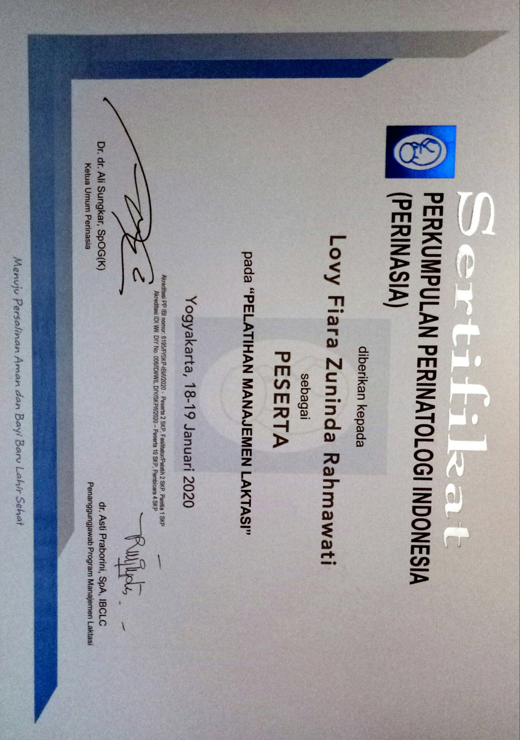**Lampiran 7**