*Lampiran 7*

LEMBAR OBSERVASI PEMBERIAN

LATIHAN PURSED LIPS BREATHING

(KELOMPOK PERLAKUAN)

Nama:

Jenis kelamin:

Usia:

Pendidikan:

Pekerjaan:

|  |  |  |  |
| --- | --- | --- | --- |
| Waktu pelaksanaan perhitungan RR | RR sebelum latihan pursed lips breathing | Waktu pelaksanaan perhitungan RR sesudah latihan pursed lips breathing | RR sesudah latihan pursed lips breathing (setelah 3 hari) |
|  |  |  |  |

*Lampiran 8*

LEMBAR OBSERVASI

(KELOMPOK KONTROL)

Nama:

Jenis kelamin:

Usia:

Pendidikan:

Pekerjaan:

|  |  |  |  |
| --- | --- | --- | --- |
| Waktu pelaksanaan perhitungan RR | RR sebelum | Waktu pelaksanaan perhitungan RR sesudah | RR sesudah (setelah 3 hari) |
|  |  |  |  |

*Lampiran 11*

Hasil uji SPSS Normalitas

**Explore**

|  |  |  |
| --- | --- | --- |
| **Notes** | | |
| Output Created | | 06-JUL-2017 10:07:49 |
| Comments | |  |
| Input | Active Dataset | DataSet0 |
| Filter | <none> |
| Weight | <none> |
| Split File | <none> |
| N of Rows in Working Data File | 30 |
| Missing Value Handling | Definition of Missing | User-defined missing values for dependent variables are treated as missing. |
| Cases Used | Statistics are based on cases with no missing values for any dependent variable or factor used. |
| Syntax | | EXAMINE VARIABLES=diff BY Kelompok  /PLOT BOXPLOT STEMLEAF HISTOGRAM NPPLOT  /COMPARE GROUPS  /STATISTICS DESCRIPTIVES  /CINTERVAL 95  /MISSING LISTWISE  /NOTOTAL. |
| Resources | Processor Time | 00:00:03.93 |
| Elapsed Time | 00:00:04.60 |

**Kelompok**

|  |  |  |  |  |  |  |  |
| --- | --- | --- | --- | --- | --- | --- | --- |
| **Case Processing Summary** | | | | | | | |
|  | Kelompok | Cases | | | | | |
| Valid | | Missing | | Total | |
| N | Percent | N | Percent | N | Percent |
| Diff | Perlakuan | 15 | 100.0% | 0 | 0.0% | 15 | 100.0% |
| Kontrol | 14 | 100.0% | 0 | 0.0% | 14 | 100.0% |
|  |  |  |  |  |  |  |  |

|  |  |  |  |  |  |
| --- | --- | --- | --- | --- | --- |
| **Descriptives** | | | | | |
|  | Kelompok | | | Statistic | Std. Error |
| Diff | Perlakuan | Mean | | 15.6667 | .86005 |
| 95% Confidence Interval for Mean | Lower Bound | 13.8220 |  |
| Upper Bound | 17.5113 |  |
| 5% Trimmed Mean | | 15.6296 |  |
| Median | | 16.0000 |  |
| Variance | | 11.095 |  |
| Std. Deviation | | 3.33095 |  |
| Minimum | | 10.00 |  |
| Maximum | | 22.00 |  |
| Range | | 12.00 |  |
| Interquartile Range | | 4.00 |  |
| Skewness | | .296 | .580 |
| Kurtosis | | -.404 | 1.121 |
| Kontrol | Mean | | 10.4286 | 1.20764 |
| 95% Confidence Interval for Mean | Lower Bound | 7.8196 |  |
| Upper Bound | 13.0375 |  |
| 5% Trimmed Mean | | 10.4762 |  |
| Median | | 12.0000 |  |
| Variance | | 20.418 |  |
| Std. Deviation | | 4.51858 |  |
| Minimum | | 2.00 |  |
| Maximum | | 18.00 |  |
| Range | | 16.00 |  |
| Interquartile Range | | 6.50 |  |
| Skewness | | -.356 | .597 |
| Kurtosis | | -.328 | 1.154 |

|  |  |  |  |  |  |  |  |
| --- | --- | --- | --- | --- | --- | --- | --- |
| **Tests of Normality** | | | | | | | |
|  | Kelompok | Kolmogorov-Smirnova | | | Shapiro-Wilk | | |
| Statistic | df | Sig. | Statistic | Df | Sig. |
| Diff | Perlakuan | .158 | 15 | .200* | .964 | 15 | .769 |
| Kontrol | .207 | 14 | .105 | .943 | 14 | .465 |

|  |
| --- |
| *. This is a lower bound of the true significance. |
| a. Lilliefors Significance Correction |

**Histograms**

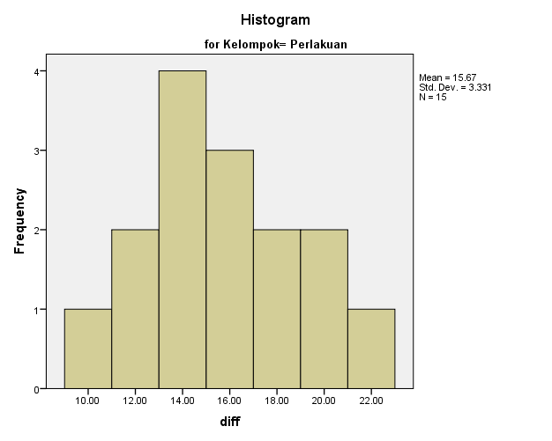

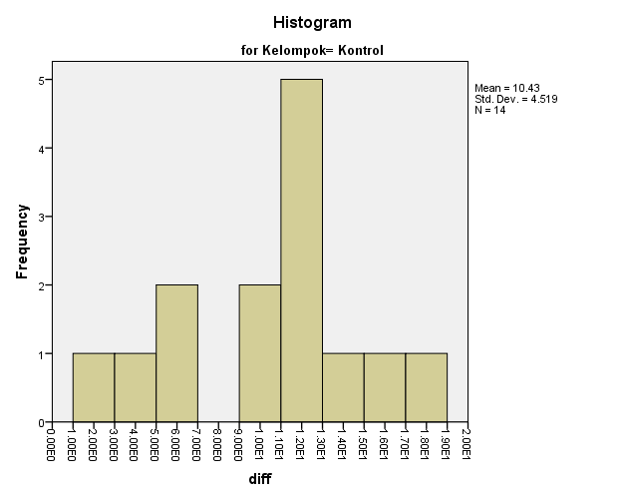

**Stem-and-Leaf Plot**

diff Stem-and-Leaf Plot for

Kelompok= Perlakuan

Frequency Stem & Leaf

7.00 1 . 0224444

5.00 1 . 66678

3.00 2 . 002

Stem width: 10.00

Each leaf: 1 case(s)

diff Stem-and-Leaf Plot for

Kelompok= Kontrol

Frequency Stem & Leaf

2.00 0 . 24

2.00 0 . 66

8.00 1 . 00222224

2.00 1 . 68

Stem width: 10.00

Each leaf: 1 case(s)

**Normal Q-Q Plots**

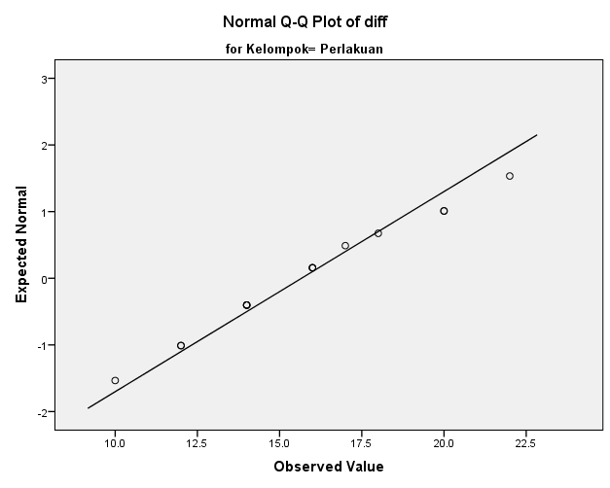

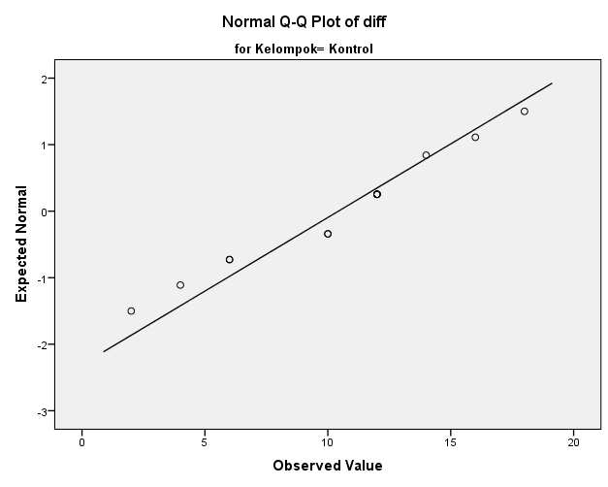

**Detrended Normal Q-Q Plots**

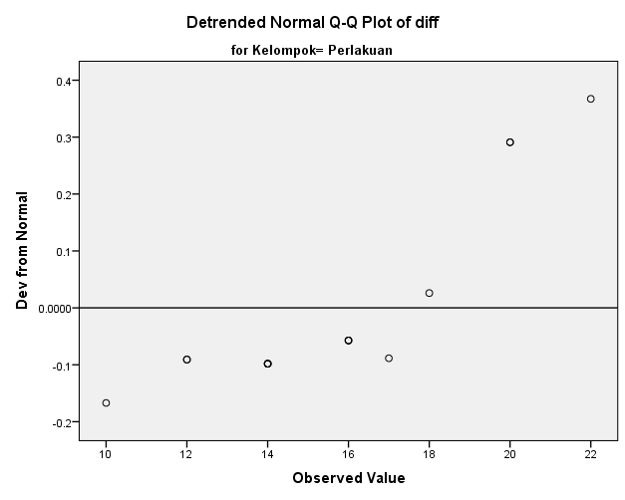

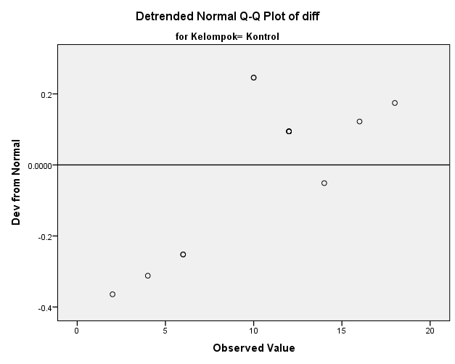

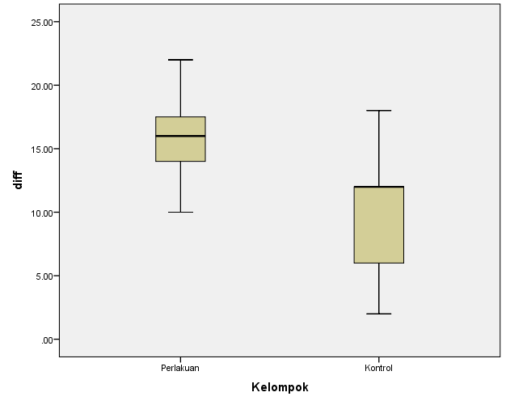

*Lampiran 12*

Hasil Uji SPSS *Paired t-test*

**T-Test**

|  |  |  |
| --- | --- | --- |
| **Notes** | | |
| Output Created | | 06-JUL-2017 10:15:39 |
| Comments | |  |
| Input | Active Dataset | DataSet1 |
| Filter | <none> |
| Weight | <none> |
| Split File | <none> |
| N of Rows in Working Data File | 15 |
| Missing Value Handling | Definition of Missing | User defined missing values are treated as missing. |
| Cases Used | Statistics for each analysis are based on the cases with no missing or out-of-range data for any variable in the analysis. |
| Syntax | | T-TEST PAIRS=Pre Pengukuran1 WITH Post Pengukuran2 (PAIRED)  /CRITERIA=CI(.9500)  /MISSING=ANALYSIS. |
| Resources | Processor Time | 00:00:00.02 |
| Elapsed Time | 00:00:00.11 |

|  |  |  |  |  |  |
| --- | --- | --- | --- | --- | --- |
| **Paired Samples Statistics** | | | | | |
|  | | Mean | N | Std. Deviation | Std. Error Mean |
| Pair 1 | Pre | 38.5333 | 15 | 3.06749 | .79202 |
| Post | 22.8667 | 15 | 2.99682 | .77378 |
| Pair 2 | Pengukuran1 | 37.6000 | 15 | 4.35562 | 1.12462 |
| Pengukuran2 | 27.7333 | 15 | 4.13118 | 1.06667 |

|  |  |  |  |  |
| --- | --- | --- | --- | --- |
| **Paired Samples Correlations** | | | | |
|  | | N | Correlation | Sig. |
| Pair 1 | Pre & Post | 15 | .397 | .143 |
| Pair 2 | Pengukuran1 & Pengukuran2 | 15 | .343 | .211 |

|  |  |  |  |  |  |  |  |  |  |
| --- | --- | --- | --- | --- | --- | --- | --- | --- | --- |
| **Paired Samples Test** | | | | | | | | | |
|  | | Paired Differences | | | |  |  |  |  |
| Mean | Std. Deviation | Std. Error Mean | 95% Confidence Interval of the Difference |  |  |  |  |
| Lower |  |  |  |  |
| Pair 1 | Pre - Post | 15.66667 | 3.33095 | .86005 | 13.82205 |  |  |  |  |
| Pair 2 | Pengukuran1 - Pengukuran2 | 9.86667 | 4.86778 | 1.25685 | 7.17098 |  |  |  |  |

|  |  |  |  |  |  |
| --- | --- | --- | --- | --- | --- |
| **Paired Samples Test** | | | | | |
|  | | Paired Differences | t | df | Sig. (2-tailed) |
| 95% Confidence Interval of the Difference |
| Upper |
| Pair 1 | Pre - Post | 17.51129 | 18.216 | 14 | .000 |
| Pair 2 | Pengukuran1 - Pengukuran2 | 12.56235 | 7.850 | 14 | .000 |

*Lampiran 13*

Hasil Uji SPSS *Independent sample t-test*

**T-Test**

|  |  |  |
| --- | --- | --- |
| **Notes** | | |
| Output Created | | 06-JUL-2017 10:11:06 |
| Comments | |  |
| Input | Active Dataset | DataSet0 |
| Filter | <none> |
| Weight | <none> |
| Split File | <none> |
| N of Rows in Working Data File | 30 |
| Missing Value Handling | Definition of Missing | User defined missing values are treated as missing. |
| Cases Used | Statistics for each analysis are based on the cases with no missing or out-of-range data for any variable in the analysis. |
| Syntax | | T-TEST GROUPS=Kelompok(1 2)  /MISSING=ANALYSIS  /VARIABLES=Pengukuran2  /CRITERIA=CI(.95). |
| Resources | Processor Time | 00:00:00.02 |
| Elapsed Time | 00:00:00.01 |

|  |  |  |  |  |  |
| --- | --- | --- | --- | --- | --- |
| **Group Statistics** | | | | | |
|  | Kelompok | N | Mean | Std. Deviation | Std. Error Mean |
| Pengukuran2 | Perlakuan | 15 | 22.8667 | 2.99682 | .77378 |
| Kontrol | 14 | 27.4286 | 4.10842 | 1.09802 |

|  |  |  |  |  |  |  |  |  |  |  |
| --- | --- | --- | --- | --- | --- | --- | --- | --- | --- | --- |
| **Independent Samples Test** | | | | | | | | | | |
|  | | Levene's Test for Equality of Variances | | t-test for Equality of Means | |  |  |  |  |  |
| F | Sig. | t | df |  |  |  |  |  |
|  |  |  |  |  |
| Pengukuran2 | Equal variances assumed | .642 | .430 | -3.433 | 27 |  |  |  |  |  |
| Equal variances not assumed |  |  | -3.396 | 23.692 |  |  |  |  |  |

|  |  |  |  |  |  |  |
| --- | --- | --- | --- | --- | --- | --- |
| **Independent Samples Test** | | | | | | |
|  | | t-test for Equality of Means | | |  |  |
| Sig. (2-tailed) | Mean Difference | Std. Error Difference |  |  |
|  |  |
| Pengukuran2 | Equal variances assumed | .002 | -4.56190 | 1.32868 |  |  |
| Equal variances not assumed | .002 | -4.56190 | 1.34327 |  |  |

|  |  |  |  |
| --- | --- | --- | --- |
| **Independent Samples Test** | | | |
|  | | t-test for Equality of Means | |
| 95% Confidence Interval of the Difference | |
| Lower | Upper |
| Pengukuran2 | Equal variances assumed | -7.28812 | -1.83569 |
| Equal variances not assumed | -7.33619 | -1.78762 |